**Escape Characters**

Escape Character: To print “ within a system.out.println() statement we make use of \”.

Newline Character: To leave a line withint a sout statement we can use \n.

Tab: To leave 8 blank spaces we use \t.

Slash: To print slash we use \\.

Declaration statement: int a = 10

Assignment: a = 20

**Variables in JAVA**

We use variable name to refer to the memory location where the value of the variable is stored.

1) A variable can only contain alphabets, numbers, $ and _.

2) A variable cannot start with a number.

3) A variable cannot be named same as that of a keyword.

4) A variable name can be of any given length.

5) Use camelCase.

We cannot write **float a = 3.5** because by default floating point numbers/literal are double data type and hence we cannot put a double value into a float because double requires 64 bits whereas float requires 32 bits. Hence, we write **float a = 3.5f**.

Since operations are executed from left to right, “1” + 2 + 3 = 123. However, “1” + (2+3) = 15

An assignment operation involves assigning the value of the expression on the ride side to the variable on the left side. We cannot have a value on the left side of an assignment operator. We can have a value/variable on the right side of an assignment operator.

**Declaring a method:** Giving a name.

**Defining a method:** Telling it what to do.

**Parameter:** Variable declared in method definition.

**Argument:** Variable/value passed when we call a method.

**How java solves the platform dependency problem** <https://www.udemy.com/course/java-programming-tutorial-for-beginners/learn/lecture/9565434#overview>

<https://www.udemy.com/course/java-programming-tutorial-for-beginners/learn/lecture/9565446#overview>

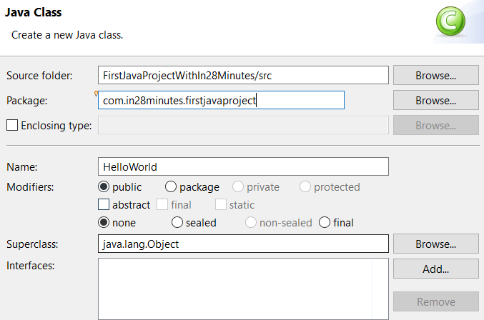

When we talk about projects, they might be containing multiple Java classes. You'd want a way of organizing these classes. You don't want all the classes or if you have hundred classes all the, all of them present one below the other in here. You'd want to be able to organize them into different groups, and packages offers you a way of doing it.

**Section 8: Introduction to OOPS**

Procedural or structured programming involves thinking in terms of procedures. These are also called methods or functions. So, let's say I have a problem to solve. The first thing I would try and do, is to split the problem into multiple functions or multiple procedures. I would start thinking in terms of okay, what are the functions I would need to write? What are the different steps involved in doing this? For example, let's say I would want to fly. So, I would want to fly from one place to another place. Then, I would start thinking in terms of the different steps involved. I'll say, okay, travel to airport, find a check-in counter, check-in, pass security check. So, we are thinking more in terms of what are the important methods that we would need to create, and how to combine them to solve the problem at hand. Procedural or structured programming is all about thinking in terms of functions or these are also called procedures.

Object-oriented programming brings a new thought process around this. It says okay, why don't we talk in terms of the different objects that are involved in the problem and also think about, what is the data they would contain and what are the actions you can perform on them. Okay, is this something complex? Then you are not alone. That's how I felt when I was introduced to object-oriented programming as well, about 15 years back. Let's take an example and try and understand how to think in terms of object-oriented programming. So, let's take the example of taking a flight again. The first thing that we would be thinking about is what are the different objects that are involved. An aeroplane, a air-hostess, a passenger, a airport, a cab that I would need to take to the airport, also, the different persons that might be involved. So, when we are thinking object oriented, we are trying to identify the different things that are involved in our problem. The first thing we should try and do is to identify the things like aeroplane, air-hostess, passenger, the pilot, and things like that. Once we identify the things that are involved, we identify what data you would want to use about that specific thing. So, what is the data that can represent an aeroplane, maybe which airline. What is the make of the aeroplane? What is the type of an airplane; whether it's an Airbus or not? And what is the position, where is it currently? So, that's kind of typically the data and also, you would think in terms of actions, you'd would be thinking in terms of the actions that you can perform on an aeroplane; take off, land, cruise, a lot of things that you can do on an aeroplane. If you look at the air-hostess, then probably the name of the air-hostess, address is the data, and there might be actions like wish, serve, and a number of other actions. When we are thinking about a passenger, his name, maybe his address, and a lot of information can be the data and probably the actions he can perform is take cab, do a check-in, walk, smile, run, board the aircraft, and a lot of such actions. So, when we are thinking object-oriented programming, we are thinking about, what are the objects, what is the data they might contain, and what are the actions that can be performed on them.

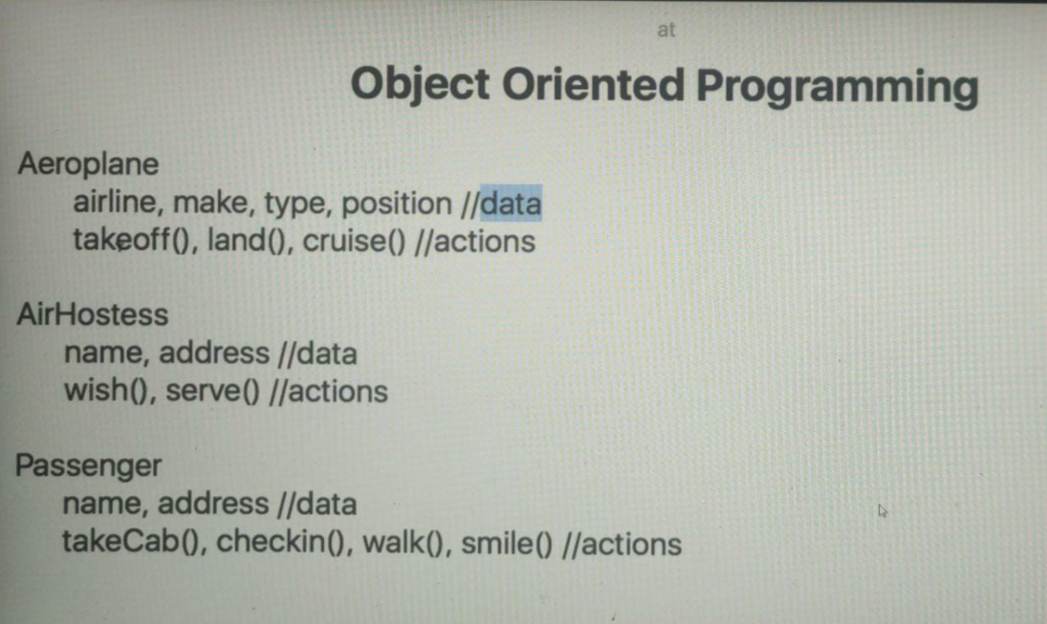

**Encapsulation**

One of the fundamental principles of encapsulation is that the objects within other classes should not access the variable directly rather, use the methods to change the state. Hence, we make the variables private which doesn’t allow the variable to be directly accessed from outside the class.

So, what we can do is we can prevent bad code from other classes, from putting bad data into your objects. That's one of the most important things about Encapsulation. If you have methods, then you can have validations around what can go into your object and what cannot go into your object as well.

**Primitive Types**

By default all number literals are considered to be an integer and hence we have to write **L** when I need to assign a long value, i.e., **long val = 1000000000L**.

We cannot write **int value = val** because val is a long and we will have a lossy conversion. However, we can force and make an explicit conversion using **int value = (int) val**. (long is a bigger data type as compared to int)

However, when we write **long val = value** then implicit casting takes place and the smaller integer value is automatically stored as a long.

Int a = 010 // 8 anything starting with 0 is octal

Int b = 0x10 // 16 anything starting with 0x is hexal

We cannot write **short a, int b; a = b;** because java sees the size of the variables and since int has a size of 4 bytes we cannot put a value which occupies 4 bytes and put it in a 2 byte space.

By default the type of a floating point literal is double and hence we write **float f = 34.5f**.

**Float Data Type**

Since both float and double are not 100% accurate it is recommended to use the **BigDecimal** built in class in Java to perform calculations which require accurate results.

**BigDecimal n1 = new BigDecimal(“34.55555”)**

**BigDecimal n2 = new BigDecimal(“25.42323”)**

**BigDecimal n3 = n1.add(n2);**

Since BigDecimal is an immutable class we cannot change the object values once they are created.

We cannot directly add two BigDecimal on data types like BigDecimal and hence we use **.add**. We cannot add an integer to BigDecimal. We can only add a BigDecimal with another BigDecimal. Hence, we write **n3.add(new BigDecimal(5))**.

**Boolean Data Type**

Operators on Booleans are logical operators. These are called logical operators because both the operands must be Booleans.

<https://www.udemy.com/course/java-programming-tutorial-for-beginners/learn/lecture/9565526#overview>

**int j = 15, I = 10;**

**&&** is known as **short circuit operator** and what it does is if the first condition is false then it doesn’t even evaluate the second condition. Hence, if we write: **If (j > 20 && i++ > 5) return true** then the value of I remains 10 because the first condition was false. However, if we use the **&** operator and write **If (j > 20 & i++ > 5)** then I becomes 11 because it still executes/evaluate the second condition.

**Char Data Type (2 bytes)**

**char ch = ‘a’;**

We can also use Unicode to generate a character, **char ch = ‘\u0022’;**

The result of an operation between a character and an integer is always an integer. (This is because integer has larger byte storage)

<https://www.udemy.com/course/java-programming-tutorial-for-beginners/learn/lecture/9565548#overview>

<https://www.udemy.com/course/java-programming-tutorial-for-beginners/learn/lecture/9566002#overview>

**For vs While Loop**

If we don’t know at the start of the loop that how many times we would like the loop to be executed, we use while loop.

<https://www.udemy.com/course/java-programming-tutorial-for-beginners/learn/lecture/9565596#overview>

**Reference Type**

Any classes defined in Java are reference types (eg String or user defined classes).

Instances of the classes are known as reference variable.

<https://www.udemy.com/course/java-programming-tutorial-for-beginners/learn/lecture/9565600#overview>

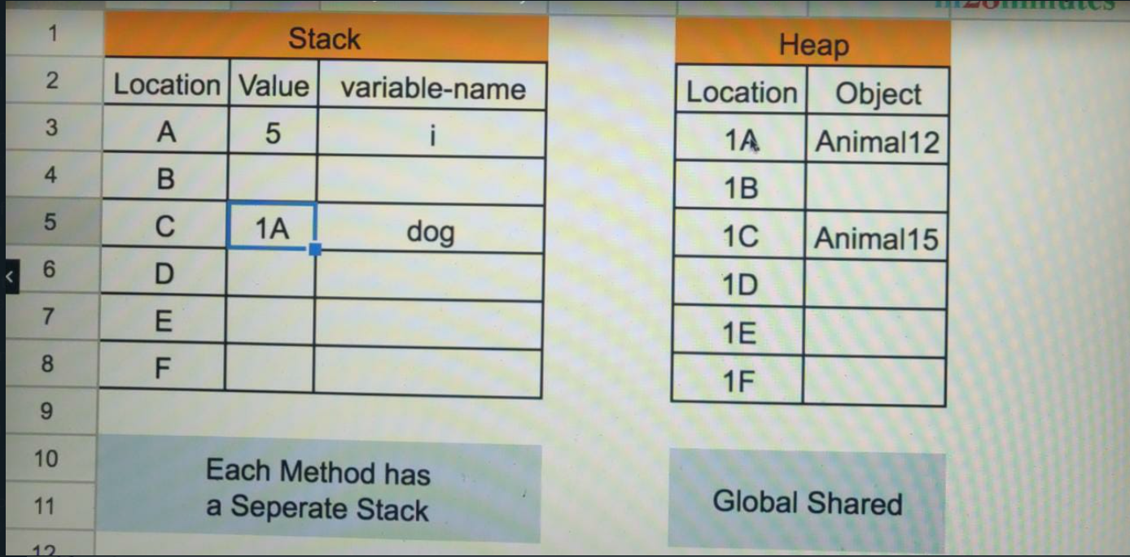

Whenever we create a new object, it is stored in a heap (Heap is a common place shared by the entire java program). When we create a primitive variable, it is always created in the stack. However, when I create a reference variable, it is stored in the heap and dog (the variable name/reference variable) stores the reference of the memory location where the actual dog object is stored. Hence, dog here is the reference variable because it refers to the memory location of where the dog/animal object exists in memory.

When we equate a reference variable to another, the location of where the object is stored gets copied. Hence, if we use either of the reference variable to change the value of the object, the value gets changed for the other reference variable aswell since both of them point to the same object in memory.

When we copy reference variables, the address of the object is copied.

In the case of primitive variables, we are storing the value whereas, in the case of reference variables we are storing the memory location.

Whenever we compare two reference variables, we compare the objects they are referring to and not the value stored in their respective objects.

**So, the important thing to understand is when we are comparing reference variables using ==, what we are just comparing is, if they're referring to the same object. If they have references of two different objects, it does not matter even if the values are the same. The answer would be false. The important thing to understand here is the == operator for a primitive variable compares the values. But for reference variables, compares if they are referring to the same object. If they are not referring to the same object, it would return false. We learnt that a reference variable, if you do not assign it a value, then it has a value of null and we also learnt that the reference variable points to a location of memory where the actual object is stored and when we compare reference objects what we are comparing is if they are pointing to the same object and when we are assigning a reference variable to another, what gets copied is the reference of where it is stored in memory. The object does not get copied.**

**String Class**

1) someString.length();

2) someString.charAt(0); (starting index = 0)

3) someString.substring(10) or someString.substring(10,12) // 10 inclusive and 12 not

4) someString.indexOf(“word”) // returns starting index of the word if its present in string

5a) someString.indexOf(‘I’) // gives index of first occurrence of the letter i

5b) someString.lastIndexOf(‘I’) // gives index of last occurrence of the letter i

6) someString.contains(“word”) // returns true/false depending on whether word exists

7a) someString.startsWith(“this”) // returns true/false

7b) someString.endsWith(“end”) // returns true/false

8) someString.isEmpty(); // returns true/false

9) someString.equals(“value”) // returns true/false

9b) someString.equalsIgnoreCase(“Value”)

**String is immutable, i.e., value of a string cannot be changed.**

If we type **String str = “Hello”** and then **str.concat(“Bye”)** then **str** still holds the value as **Hello** and the str.concat function in fact returns a new string.

1) str.toUpperCase() // converts a new string to uppercase

2) str.trim() // removes whitespaces at the start and the end (not of the original string)

If we use **+** for concatenation and one of the operand is a string then concatenation takes place.

1 + 2 + “3” = “33”

“1” + 2 + 3 = “123”

The above is because expressions in java are evaluated from left to right and till “3” is encountered in the first expression we only have integers and normal addition takes place.

System.out.println(“Hello” + 20 + 20); Output = Hello2020 (concatenation between a string and an integer)

1) String.join(“,”,”A”,”B”) // “A,B”

2) str.replace(‘a’,’z’)

If we perform String str = “xy” + “zw” + “ab”; we are making 2 extra string objects when we concatenate them (xy+zw and xy+zw+ab) apart from the 3 needed ones. Hence, a lot of objects are created unnecessarily and to avoid that we use **StringBuffer class.**

**StringBuffer str = new StringBuffer(“ab”);**

StringBuffer is mutable. str.append(“xyz”) will change the value of str aswell.

Since we can change values in stringbuffer its preferred to use when we have to perform a lot of concatenations.

<https://www.udemy.com/course/java-programming-tutorial-for-beginners/learn/lecture/9565614#overview>

There is another class which is offered in Java which is called StringBuilder. StringBuilder is very very similar to StringBuffer. But it's offered in the later versions of Java because StringBuffer is a synchronised class. So, what does that mean? That means, that StringBuffer is a class which is ready for multithreading. But if you are ready for multithreading, it means that there is a penalty which is imposed on you. That means when you're running in a single-threaded scenarios where you don't really need all the complexities around multithreading, StringBuffer might get really slow and in those kind of situations, you can use StringBuilder. We'd talk about multithreading and all that kind of stuff a little later in this course in a separate section. But for now, you can think that if you don't really worry about multithreading, then you can use a String Builder. So, instead of a StringBuffer, you can use a StringBuilder. So, I can say StringBuilder sb = new StringBuilder with your string. If you further explore the APIs of StringBuffer and String Builder, you would see that there are variations in the methods that they offer and things like that. But effectively, the thing which you'd need to remember is this. If you're concatenating a lot of strings and creating a lot of instances of strings, then it's recommended to go for the alternatives, either the StringBuilder or the StringBuffer. If you don't worry about multithreading, then you would really be advised to go with the StringBuilder class. If you want your code to be thread-safe, then you'd go for the StringBuffer class.

**Wrapper Classes**

Classes corresponding to different primitive types are called as wrapper classes in Java.

Why do I need a wrapper class? The thing about wrapper classes is, they offer you a lot of options, additional options. Let's say I would want to create a boolean value from a string or I would want to create a integer value from a string. You can do that using wrapper classes. The other things that wrapper class provides are a number of utility methods. So, let's say, I have a float and I would want the integer value of that specific float. I can use a intValue( ) method. Let's say I want to convert a string which is in binary format. So, binary is 0 and 1s. So, let's say, I have a string in the binary format and I would want to convert it into integer representation. There are a lot of utility methods like this which are offered by the wrapper classes. And also, wrapper classes allow you to store primitive values into a collection. We will talk about collections, a little later. If you want to add anything to a collection, it must be an object and wrapper classes provide the objects around these primitives.

Creating wrapper classes:

**Integer int = new Integer(5);**

**Integer int2 = new Integer(5);**

**Int == int2 // false** since these are reference variables and for reference variables == does not compare the value but rather where they are stored in the memory.

**Integer int = Integer.valueOf(5);**

**Integer int2 = Integer.valueOf(5);**

**Int == int2 // true**

Over here, what is happening is, for i1, a new integer variable is getting created and i2, another integer variable with the same value is getting created. What Integer.valueOf( ) does is okay, why do I need to create another instance of the same value? It would check and re-use if there is an existing object of the integer with the same value. If it finds another object with the same value, it would try and re-use and it would return the same thing back.

That's okay because the value of that object will not change. Integer is immutable. You cannot change the value of it. So, having two reference variables pointing to the same object is not a problem at all. What we would recommend is to use Integer.valueOf( ) or the valueOf methods to create any of the wrappers, because valueOf tries and reuses whatever objects are already created. So, it does not create a new object every time. When you use a new, you are creating a new object every time.

**Integer int = new Integer(“1234”);** // we can pass strings

**AutoBoxing**

<https://www.udemy.com/course/java-programming-tutorial-for-beginners/learn/lecture/9565622#overview>

Auto Boxing allows you to write code with primitive values, but compiler does a lot of work for you and converts them into wrappers.

Till now, to create the wrapper classes we had to write **Integer int = Integer.valueOf(5);** however, we can also write **Integer int = 5**. What happens is when you do this, Java in the background would do this, Integer.valueOf(7) and create an instance of it and put the reference of it in int. This feature in Java is called Auto boxing. Features like this are called syntactic sugar, right. Who wants to type in the extra characters?

Having looked at all these features on the wrapper classes, the last thing which we want to talk about wrapper classes is the different constants, which are defined on each of these wrapper classes. So, if you look at the wrapper classes, they have a MAX_VALUE. It indicates what max value can an integer hold. They also have a MIN_VALUE; what is the minimum value that an integer can hold. If you want to find the size of an integer, you can do that as well and you can get the size in bytes as well. So, size is in bits. So, this is 32 bits and this is 4 bytes. These kinds of constants are present on all the wrapper classes.

**Dates data type**

Java 8 brings in three most important classes. So, LocalDate, LocalDateTime, and LocalTime. These are the three classes which makes playing with date and time very easy. LocalDate is in a package called Java.time.

**LocalDate today = LocalDate.now();**

**today.getYear(), today.getDayOfWeek(), today.getDayOfMonth();**

<https://www.udemy.com/course/java-programming-tutorial-for-beginners/learn/lecture/9565628#overview>

**Section 13: Arrays and ArrayList**

arrayName.length // here length is a property of an array unlike the length method of string.

**Int[] arr = {1,2,3,4,5}** // shortcut

**Int[] arr = new Int[5]** // when elements are not know prior to making the array

Left side is declaration side and right side is definition side.

Class Person {};

Person[] obj = new Person[5] // Person array or we can say an array of objects of class Person

**Arrays.toString(arrayName)** to print an array (this is a static method of the arrays class).

**Arrays.fill(arrayName,100)** fills all values in the array as 100

**Arrays.equals(arr1,arr2)** compares arr1 and arr2 and returns a Boolean value.

**Arrays.sort(arrName)**

We can create and pass an array like a parameter

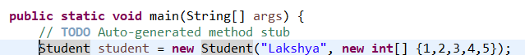

**Variable Argument Concept**

**void print(int…values) { System.out.println(Arrays.toString(values);}** // now we can use print(1), print(1,2) and pass any number of arguments to this method without overloading it. Whatever we pass to this method becomes an array of values.

Variable argument must be the last argument in a method.

Problems with array:

1) Once we set the size of an array, we cannot change it (increase or decrease). Hence, we use ArrayList.

**ArrayList**

We can add and remove elements easily here because in array it was not possible to change the size dynamically and hence we had to create a new array.

**ArrayList arr = new ArrayList();**

**arr.add(“Apple”);**

**arr.remove(“Apple”);**

**ArrayList<String> arr = new ArrayList<String>();**

**Section 14: More on OOPS**

When we are talking about a class we need to think about the state (variables), how we wanna allow the creation of objects (constructors) and the behaviour of objects (methods).

**Object Composition:** Having an object inside another object.

**Eg: Customer, Address and CustomerRunner classes in ObjectOrientedProgramming project.**

The important thing to get out of all this series of videos about object oriented programming is the way we are approaching object oriented design, right. So, first thing is we would decide the classes, then we would decide the composition, how each class is composed. Over here, we decided the customer would have two instances of the address class, that's called Composition. And then we would decide about how you'd want to allow creation of the objects. After that, you'd start thinking about the different operations that are involved. The focus behind these steps has been to get you initiated with object oriented programming thinking.

**Inheritance IS A RELATIONSHIP (extends keyword)**

To prevent code duplication, we make use of inheritance (have to change code at multiple places incase of a discrepancy).

By using extends we are inheriting a class. The base class is known as the super class and the child class is known as the sub class. Sub class extends the super class and gets all the features present in the super class.

All classes extend the **object** class.

**Method overriding:** Overriding the method implementation within the sub-class which is provided by the super-class.

**We need to call super.toString() method in the child class (within the toString() method of the child class) or else the base class toString() method wont be executed.**

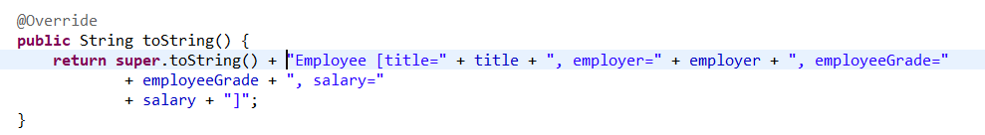

**Abstract Class**

Allows us to provide only the declaration of a method and not the implementation of it. Subclasses provide the implementation of that abstract method.

**abstract class Animal {**

**abstract public void bark();**

**}**

If a class wants to extend an abstract class, then either it needs to be an abstract class itself or provide the implementation of all the abstract methods.

We cannot create an instance of the abstract class.

An abstract class can extend another abstract class. **abstract class Pet extends Animal {}.**

Abstract classes can have variables defined in them and also methods with concrete definitions (implementations) defined in them (non-abstract method).

What the abstract class allows us to do is to define the basic algorithm. We are defining the different steps which are involved. So, we are saying getReady( ), dotheDish( ), and cleanup( ). And we are providing the actual implementation of the steps in the subclasses: Recipe1 and RecipeWithMicrowave. This is exactly what most of the abstract classes do in various kind of frameworks, right. So, there are a number of Java frameworks which are present and all the abstract classes provide kind of the sample algorithm. So, they implement the high-level algorithm and they leave the specific details to the implementation classes, to the classes which are extending the abstract class. This is one of the ways in which abstract classes are typically used.

**Interfaces**

Let us take the example of a gaming console. So, in there, whatever buttons that are present in here is the interface that is present to the game, right. So, whatever game you're playing would actually implement something for each of these buttons. So, when you press this button, what should happen? That is what the Games would implement. Let's say you are playing a Mario game or a Chess game, these games provide implementations to the different things which are present on this interface. And that's exactly how you would need to start thinking about interfaces in Java or for that matter in any object-oriented programming language.

We only define the syntax of the methods and not their implementation. is not really available. The way you can actually think about interfaces is It establishes the communication agreement; it establishes the contract between two classes which are talking to each other. So, what are the methods that a specific class is definitely going to implement and all the other classes in the system can depend on the fact that that particular class would contain all those methods.

**An interface can extend another interface. When we want to implement an interface which is extending another interface then, we need to provide an implementation of the parent interface as well. However, what if we don’t want to provide an implementation for the methods of the parent interface? In that case we can create an abstract class which implements the child interface. An abstract class can implement parts of the methods which are defined in the interface, this is allowed. However, any concrete class which extends the abstract class needs to implement everything present in both the interfaces (the abstract class and the concrete class together should provide an implementation for all the methods in the interfaces).**

**We can create constants in an interface and not variables. (We can write int a = 5; and not int a; in an interface)**

**Before Java 8 creating an implementation of a method inside an interface was not allowed. However, now its allowed. This is acting as a default implementation for this method in the interface and the classes implementing this interface can either override this method or use the default implementation.**

interface Interface1 {

default void print() {

System.out.println(“Hello”);

}

};

The use of the default methods is typically, when you are extending an interface. Let's say, I have an interface with three methods and I have 1000 classes implementing those three methods. Now, if I add a fourth method to the interface, all the 1000 classes will start having a compilation error.

We saw that an interface can extend another interface and if I want to implement a class which is not implementing every method which is present in the interface, then I can make it abstract. And also, we talked about the fact that there are default methods in interfaces from Java 8 which help you to provide a default implementation for a specific interface. Implementers of that specific interface can override the implementation, but the default is useful in cases where we are extending an interface, and we would want to prevent the implementers of that interface from having compilation issues.

**Abstract Class vs Interface**

So, when do you go for a interface? When we would want to have two systems talking to each other, or two classes, or two components talking to each other and we would want to establish a communication pattern between them. We will define a method saying, Okay, this is how these two things will talk to each other, and one party would provide the implementation, and the other party would consume the interface right. So, that's basically where interface comes in. Abstract class comes in, in a little bit of a different context. Over here, with an abstract class, what we want to provide is a high-level structure. We would want to leave the implementation details to the subclasses. What we are doing in here is we are saying okay, I would want to be able to ensure that all subclasses meet this structure. And to be able to use abstract class, we are going to use inheritance. So, IS A relationship exists between the subclasses and the superclass, which is the abstract class.

There is no real relationship. But when it comes to the syntax, you can try and compare them a little bit. So, one of the important thing is in a interface you cannot call something as private. I cannot call a method as private because in interface everything is public. So, in an abstract method, on the other hand, you can have private methods. So, you can say something is private. The other thing is in an interface you cannot have variables. You cannot have things which whose value change. If you have of a value like this, in the interface it is actually a constant value; this value cannot change. However, in an abstract class, similar to a class, you can have all kinds of variables. Because abstract class is nothing but a class, except that some of the methods in the abstract class might not have a concrete implementation. The other difference between an abstract class and an interface is that a class can implement multiple interfaces, ArrayList for example, which is one of the things which we discussed earlier. So, ArrayList, if we look at it, it implements a number of interfaces. So, it implements a List interface, a RandomAccess interface, a Cloneable interface, a Serializable interface. But the thing is, a class can implement multiple interfaces, but you cannot extend multiple abstract classes. So, you cannot have two superclasses, right. It basically comes down that you cannot inherit from two different classes.

**If you have multiple implementations of the abstract class, polymorphism is a default consequence of it.**

**Section 15: Collections in Java**

Why do we need Collections? Let's look at that in this specific step. In the previous sections, we talked about Arrays. We talked about the facts that Array is a fixed-length, right. So, once I create an Array with a specific length, I cannot change the length of an Array. So here, we have an Array of 15 elements, index runs from 0 to 14 and let's say, I would now want to insert a new element, 100 at the index 2. So, at this location, I would want 100 to be inserted. What I would need to do is to write a lot of new code, right. I would need to write code to create a new Array with 16 elements. After that, I would need to copy the first two elements and then insert the new element, 100 into it and after that I would need to copy the rest of the elements. That's a lot of work and that's what ArrayList does for you. **ArrayList is a Collection**. Similar to Array, there are a lot of other data structures, how you can store your data: LinkedList, Hashtable, Tree. The question Java asks you is, do you want to focus on the low-level data structures or do you want to focus on your business logic? And, Java also provides a solution for that.

Java provides a number of built-in Collections. Some of the important Collection interfaces that Java provides are List, Set, Queue, and Map. You can use these Collections to solve a wide variety of problems. In the next steps, we would learn about each of these Collections, what are the different variations that are present with each one of them, and how do you choose the right Collection for the right problem. In this video, we looked at why we need Collections. The underlying data structures are very complex. Even inserting a simple thing into an Array or deleting a simple thing involves writing a lot of code. Other data structures like Tree, LinkedList are even more complex.

Java provides implementations of these data structures called Collections. So, you can focus on the business logic and don't really need to worry about what's happening beneath them. What we'd need to get is a good understanding of each of these Collections and what is a data structure underneath it and when is the right time to use which Collection.

**1) List Interface**

Ordered collection of elements.

Allows duplicate elements.

Elements can be added in by specifying the position where it should be added in.

If element is added without specifying a position then it is added at the end.

**Initialising a list: of() is a static method present inside the list interface.**

List<String> words = List.*of*("Apple", "Mango");

**size() is a method available in collections to find out the number of elements within the collection.**

**isEmpty() is used to check for emptiness of the collection.**

**words.get(0) // returns element at index 1**

**words.contains(“Apple”) // to find out if the list contains this element or not**

**words.indexOf(“Apple”) // returns the index of the element**

**\*\*\*SideNote: Immutability is when we cannot change the value of an instance of a class after its creation\*\*\***

Anything we create with **of()** function becomes an immutable list and we cannot add more elements to it. To make a mutable list we can either create an ArrayList, a LinkedList or a Vector.

List<String> wordsArrayList = **new** ArrayList<String>(words);

and now I can add values in this wordsArrayList. (**wordsArrayList.add(“Banana”);**

**ArrayList vs LinkedList**

Now, let's start with the basic data structure which is used underneath these. Underneath ArrayList, the basic data structure which is used is an Array and same is the case with an Vector. However, with a LinkedList, the data structure which is used is a LinkedList.

Underneath an ArrayList or a Vector is an Array. Underneath a LinkedList, is a data structure called a LinkedList. So, in an Array, the values are present next to each other and therefore I would be able to get a specific value at location 8. If I want to get it, I can get it very fast. However, with an Array, inserting values and deleting values is a time consuming operation. If I want to insert an element here, then I would need to move all the other elements one step to the right and insert a new element in here. I would also have to create new Arrays in certain situations. If I have to delete 50, then I have to delete this and move all the elements to the right, one step to the left, right. These are costly operations because there are multiple elements that I would need to move up and down.

The other kind of data structure is a LinkedList. In a LinkedList, you have a reference from one element to the other element. So, the way elements are stored, if I am storing six elements like this is, I would have a link from 45 to 25, 25 to 4, 13, and 6. So, if I want to find the 5th element in a LinkedList, then I have to start from here and say 1st element, 2nd element, 3rd element, 4th element, and 5th element. So, trying to access something from a LinkedList is very slow. But if I would want to delete an element from a LinkedList, let's say, I would want to delete 6 from the LinkedList, then all that I would need to do is delete this element and change the next value of 13 to 5. So, change the link 13, it's link would change to point to 5. Or, if I would want to add a element in between, so between 45 and 25, let's say, I would want insert 100, then I can change the link from 45 to 100 and 100 to 25.

**So, the important thing is to understand that the underlying data structure beneath a ArrayList and a Vector is an Array and beneath a LinkedList is a LinkedList. For an Array, insertion and deletion are costly and accessing a value from the Array is very fast. For a LinkedList, inserting an element and deleting an element is much more easier than an Array. But accessing a element at a specific location based on the index or trying to search through the LinkedList is a little more costlier.**

Trying to find an element at a specific index is a much more costlier operation with LinkedList because you have to go through an element by element.

In summary, ArrayList, insertion and deletion are slower compared to a LinkedList and it allows a constant time-access. However, with the LinkedList, elements are doubly linked. In the picture, we saw only the forward link. Actually in the LinkedList implementation in Java, we use something called doubly LinkedList. That means you have a link forward and also a link backward. So, you have a link to the forward element and the backward element as well. As we discussed, iterating through a list is very very slow, because you have to move from one element to another element and also accessing a specific element is slower. So, if I want to access 5th element, it would be faster in an ArrayList compared to a LinkedList. However, LinkedList would have faster insertion and deletion. So, think about when you would use an ArrayList, when you would use an LinkedList. When you have very few insertions and deletions, very few modifications in the list, and you would want to access the elements based on their position, you'd go for an ArrayList. If you have a number of insertions and deletions, then you would go for your LinkedList. We saw that the underlying data structure beneath an ArrayList is an Array, LinkedList is a Doubly LinkedList which has a link to the forward element and the backward element.

**ArrayList vs Vector**

When do you choose a Vector? When do you choose a ArrayList? If you look at the Vector class, it's present since Java Version 1. So, it's present from the first version of Java. However, ArrayList class is only present since Java 1.2. So, ArrayList came later. Before that, whenever you wanted to use a list, you had to use a Vector. Now, what is the problem with a Vector and why did ArrayList come into picture? Let's see the difference between the code. Let's pick up a couple of methods from ArrayList and the Vector classes. So, trimToSize( ), for example in Vector is synchronized. However, in ArrayList, it's not synchronized. If you look through all the other methods, you'd see that there is synchronized on most of these. However, when you get to the ArrayList, you'd see that there is no synchronized on these specific methods. What difference does the synchronized keyword make? Let's say, you have 25 synchronized methods in a class. What happens is, if this instance of this class, if a instance of the Vector class is shared between multiple threads, then only one of those threads can be executing any of these 25 methods. So, at a particular point in time, only one thread can be executing any line of code inside these synchronized methods. Why do you want to do that? Because you want your programs to be thread-safe. The behavior of your program should not change when you are accessing it from one thread or 15 threads and that's what synchronized tries to do. We looked at what is the fundamental difference between a Vector and an ArrayList? The important difference is that Vector, all methods are synchronized. That means Vector is thread-safe, in the sense that you can use Vector in situations where you are sharing data between multiple threads. However ArrayList is not thread-safe. One of the things you'd need to always remember is, thread-safety does not come free. It has a performance impact, because when one thread is executing a piece of the synchronized method, then other threads might be waiting for that thread to complete execution of the synchronized method.

Unless you need thread-safety, you would go for an ArrayList. If you would want threat-safety, then Vector is one of the options that is present. Synchronized is one of the basic ways to implement thread-safety. There are a number of approaches to thread-safety that have evolved in the last decade or so. And, Java also provides those options. Those are called Concurrent Collections and we would look at Concurrent Collections after we look at threads and thread-safe.

**Different Operations that we can perform on these lists**

By default the list which we create using **list.of()** is an immutable list. Hence, we can use the following 3 ways to create lists:

List<String> words = List.*of*("Apple", "Mango");

List<String> wordsArrayList = **new** ArrayList<String>(words);

List<String> wordsLinkedList = **new** LinkedList<String>(words);

List<String> wordsVectorList = **new** Vector<String>(words);

A list can have duplicates.

1) Adding an element: wordsArrayList.add("Grapes");

1b) Adding an element at a specific position: wordsArrayList.add(1,"Grapes");

2) Adding elements of another list to arrayList: wordsArrayList.addAll(newList);

3) Change the element at an index: wordsArrayList.set(6,"Fish");

4) Deleting an element based on the index: wordsArrayList.remove(2);

5) Deleting an element based on element (1st inst. gone): wordsArrayList.remove("Fish");

6) Iterating: **for**(**int** i = 0; i < wordsArrayList.size(); i++)

System.out.println(wordsArrayList.get(i));

**for**(String word: wordsArrayList)

System.out.println(word);

Iterator wordsIterator = wordsArrayList.iterator();

**while**(wordsIterator.hasNext())

System.out.println(wordsIterator.next());

When you're using an enhanced for loop, in the middle of the loop it is not recommended to make modifications, especially deletions from the list. Because you are removing a word from that specific List and it might change how the iteration happens. In these kinds of situations, it is recommended to go with a iterator. So, if you want to remove an specific word from a List, the best approach would be to use a iterator. To make a modification in between a loop to an ArrayList, the best way to do that is by using a iterator. So, iterator is the best way to delete. If you're just looping around it, then probably an enhanced for loop is the best way to go with it. However, if you are trying to make a deletion or something of that kind, then it's better to go with an iterator, it's safer to go with an iterator.

We cannot store primitive in a list. **List list = List.of(1,2,3)** will autobox this and a wrapper class (Integer) gets created. If we only want out list to contains strings, we use generics and type **List<String> list = List.of(“Hello”);**

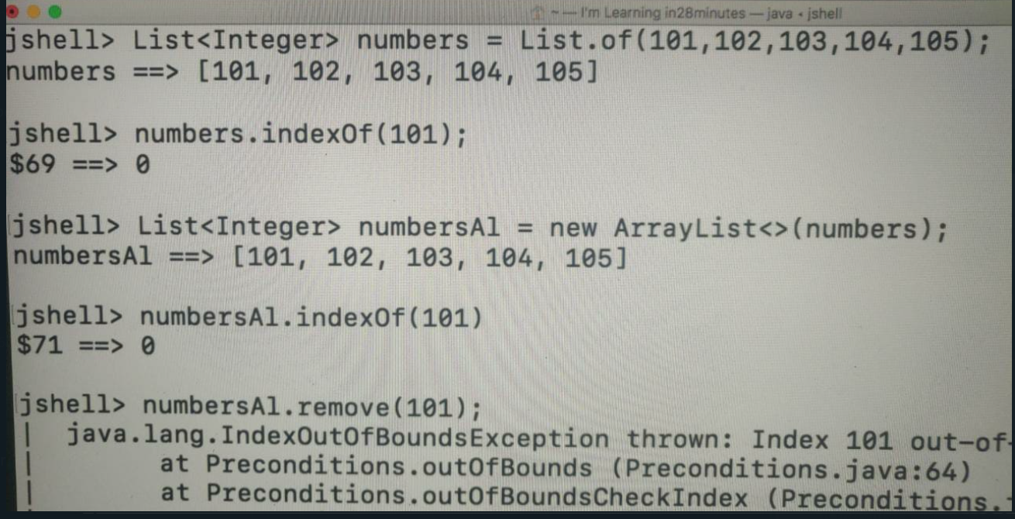

Since the indexOf() method is not overloaded, java autoboxes 101 to Integer and performs the required operation. However, remove() method is overloaded with parameters as Obj and int, and that’s why autoboxing does not take place and the int overloaded method is matched.

7) Sorting: If I want to use the sort() method by default inside the List interface then I would need to use a comparator. **Eg numbersAL.sort();**

We can use the static sort() method present in collections: **Collections.sort(numbersAL);**

Now, lets try to create an arrayList of objects and sort them: **Collections.sort(studentsAl); would show a compilation error because we can only pass ArrayList with those classes (such as Integer, String) which implement the comparable interface.**

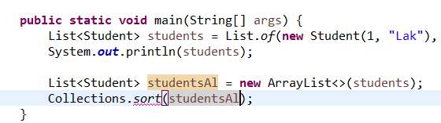

Hence, for students class we need to implement the comparable interface so that our program can know how to compare two student objects and thereafter sort them.

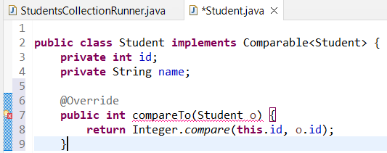

Passing in a comparator object:

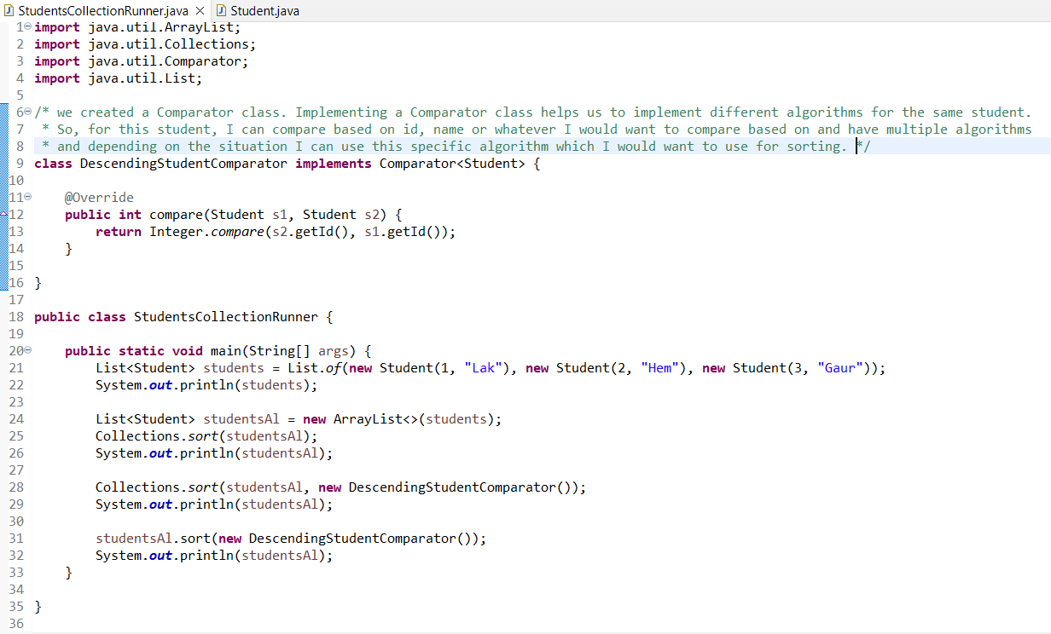

**2) Set Interface**

The Set interface extends the Collections interface but does not really provide a lot of new methods. Then, what is the need for a Set interface? The most important thing about a Set interface is you can only have unique things. You cannot have duplicates in a Set. If two objects are equal, then only one of them can be in the Set. The other thing is compared to the List interface, Set interface does not provide positional access.

**Set<String> set = Set.of(“Apple”,”Banana”);**

The order is lost after creating a set. Set by default does not allow modification (cannot use the add() method) and hence we create a hashet which is an implementation of set.

In summary, in a Set, you would not be able to have duplicates and in a Set, the position is not really important. So, you cannot say I would want to add a element at a specific position. Those are the two important differences between a Set and a List. Set is used to store unique values.

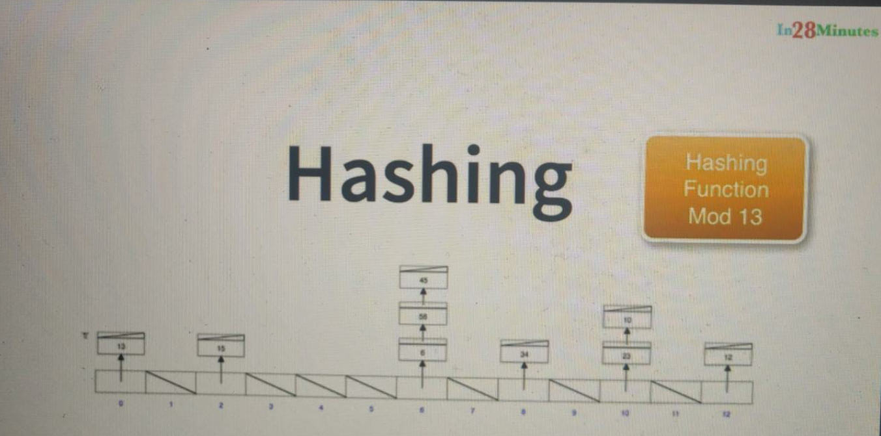

The data structure that we want to focus on in this step is called HashTable. It takes a completely different approach on how it stores elements. It tries to combine the fixed positions similar to an Array and the advantages of the LinkedList. For example, here we have 13 different positions which are present in here. These 13 things in here are called buckets and you store elements into each of these buckets. How do we store elements into this bucket? We have something called a hashing function. So, let's say, I would want to decide where I want to store 15, which bucket do I want to store 15. What I would do is, I'll evaluate the hashing function 15. The hashing function we are using in here is Mod 13. So, we would divide by 13 and take the remainder and put the element in that bucket. For example, over here, 15 Mod 13 is 2. That's why it's in the second bucket. If I want to put 34, you can see it in the bucket with index 8. That's because 34 Mod 13 is 8. 34 is, two times 13, is 26, 34-36 is 8. That's why it's at index 8. You can see that 13 is at index 0 because 13 Mod 13 is 0. So, what we are doing is, we are using something called a Hashing Function. The Hashing Function is used to decide which bucket an element goes into. Let's say, now, I would want to insert 2 into this list. What would happen? I would do 2 Mod 13, the bucket number is 2. So, I would want to store it in here. There is already 15 in here. So, what we would do is, we would attach 2 to this list. So, in addition to 15, we will have 2 in here. Let's say I would want to delete 34. All that I need to do is, 34 Mod 13, I'd get 8. I'll come here and see if there is 34 and if 34 is there, this element is deleted. Let's say, I'd want to find out if an element 4 is present in this specific HashTable. I would do 4 Mod 13, 4 Mod 13 is 4. So, I would check at index 4. At index 4, nothing is present. So, 4 is not present in this list. The advantage of a HashTable is that you can easily insert elements in and you can search for elements and you can delete elements much more easily. HashTable provides very fast searches. Insertion of elements can be a little slower than the LinkedList at certain point in times, but it's much faster than an Array. The efficiency of the HashTable will always depend on the efficiency of your Hashing Function. In Java, we would implement the Hashing Function using something called hashcode. If we look at the object class, there is a method called hashcode( ). That hashcode is used to determine which bucket an object gets stored.

**In summary, the key part of a HashTable is the Hashing Function. We use the Hashing Function to decide which bucket to store an element into and if there are elements attached to that bucket already and you are trying to insert a new element, it would be added to the list of elements. HashTable makes searches also very easy because you directly go to the bucket and look for the elements. So, you are not really searching the entire list of elements, but a set of certain elements inside that particular bucket. Similar logic applies to insertion as well as deletion of elements as well.**

**HashSet and LinkedHashSet and TreeSet**

Hashset doesn’t store the values in the order in which they are inserted or in the ascending order. LinkedHashSet on the other hand stores the values in the order in which they inserted.

TreeSet stores in the values in the sorted order.

If you don't care about neither, then you'd go for a HashSet. Out of all these, HashSet is the most efficient. But LinkedHashSet provides you with insertion order and TreeSet provides you with sorted order.

The methods which can be performed on a HashSet and LinkedHashSet are same as that on a collection. A TreeSet provides us with more methods as the data in it is sorted.

**TreeSet in Depth**

However, a TreeSet provides you more operations because the data in it is sorted. What TreeSet provides is a implementation of something called a NavigableSet and because of TreeSet implementing a NavigableSet, we would get a few features from that.

TreeSet also implements a NavigableSet interface. That means, it provides a few other operations which are traditionally not present in the Collections interface. These kind of operations are only present on Trees, on places where there is data, which is sorted.

1) **name.floor(40);** // provides element just equal to or before 40 present in the TreeSet

2) **name.lower(40)** // not inclusive of 40 (unlike floor)

3) **name.ceiling(40)**

4) **name.higher(40)** // only greater

5) **name.subSet(20,80)** // returns numbers between 20 and 80 (lower limit inclusive and upper not)

5b) **name.subSet(20,true,80,true)** setting both limits as true

6) **name.headSet(20)** returns elements before 20

6b) **name.tailSet(20)** returns elements after 20

**3) Queue Interface**

A Queue is used when you'd want to arrange things in the order you would want to process them. For example, a to-do list, right. So, for example, as soon as I come in in the day, I would have a list of things to do and as new things come in, I would take them and put them in the right place in the to-do list, so that I can pick them up when the right time for them comes.

The important thing is Queue also extends Collection. So, it supports all the Collection methods. In addition to the Collection methods, Queues support methods called add, offer, remove, poll, and peek.

The implementation of the Queue that we would be using is something called a Priority Queue. In a Priority Queue, by default, elements are stored in a sorted natural order, in the order in which you'd want to process them. However, we'll see later that we can provide custom comparator implementations to change the order. So, if you want to have a specific custom order in which you would want the elements to be processed, we can do that as well.

Queue<String> queue = **new** PriorityQueue<>();

1) queue.offer("Apple"); add an item

2) queue.addAll(List.*of*("Zebra", "Monkey")); add a list of items

3) queue.poll(); removes the first item

We can also create a comparator class and pass an instance of it (object) to the priority queue constructor.

**import** java.util.Comparator;

**import** java.util.List;

**import** java.util.PriorityQueue;

**import** java.util.Queue;

// making a comparator <string> because it implements comparator for a string

**class** StringLength **implements** Comparator<String> {

@Override

**public** **int** compare(String s1, String s2) {

**return** Integer.*compare*(s1.length(), s2.length());

}

}

**public** **class** UsingQueue {

**public** **static** **void** main(String[] args) {

Queue<String> queue = **new** PriorityQueue<>(**new** StringLength());

queue.offer("Appleman");

queue.addAll(List.*of*("Zebra", "Monkey"));

System.***out***.println(queue.poll());

System.***out***.println(queue.poll());

System.***out***.println(queue.poll());

}

}

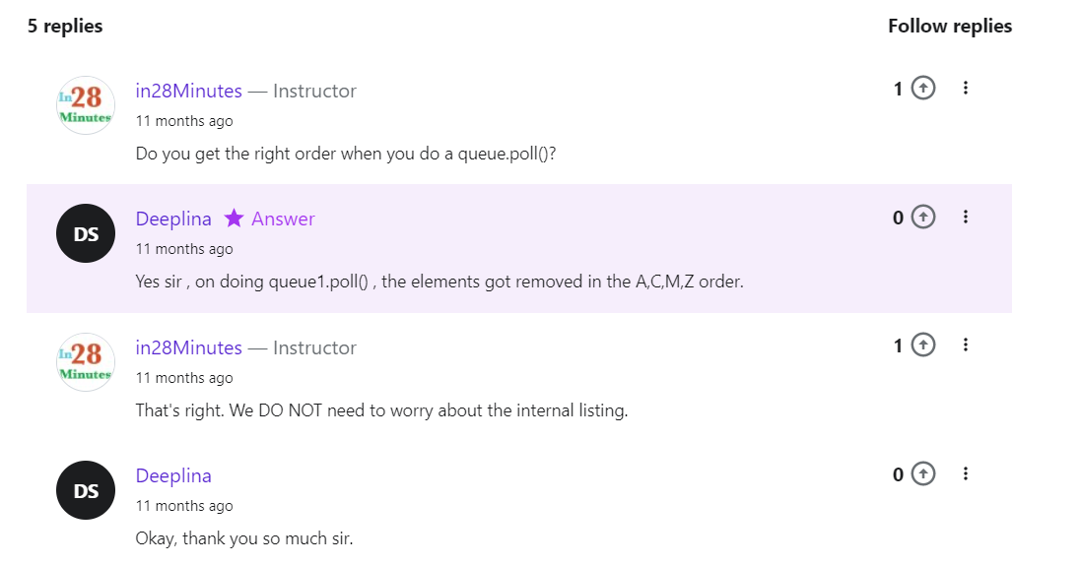

**4) Map Interface**

Map interface. The most important thing about a Map interface is, it does not extend Collection interface. So, all the operations related to Collection do not really apply to Map. So, Map is part of the Collections framework, but it's not really implementing Collection interface. Map is used to store Key - Value pairs.

There are four important implementations of the Map interface: HashMap, Hashtable, LinkedHashMap and the TreeMap.

Difference implementations of a map:

a) The first implementation that we would be looking at is HashMap. HashMap, think about what would be the underlying data structure. It would be, you are right, it's a Hashtable. So, in a HashMap, as usual, it's unsorted and unordered.

b) The next one is a Hashtable. What is the difference between HashMap and a Hashtable? Hashtable also uses the hashing technique underneath in the data structure. So, there is no difference as far as the operations are concerned between the Hashtable and the HashMap. However, Hashtable is like Vector. It's synchronized. All the methods in the Hashtable are synchronized. So, it's more thread-safe than the HashMap and just like HashMap, it's unsorted and unordered. The other key difference between the Hashtable and HashMap, which is kind of a typical interview question is that, HashMap allows to store a Key with null value. So, in a HashMap, you can store a Key with null value. However, that is not allowed in a HashTable.

c) The next Map implementation is a LinkedHashMap. Just like the LinkedHashSet, over here, the insertion order is maintained. However, it's not sorted and because of the insertion order, it would have little slower insertion and deletion than the HashMap. But the iteration, looping around the elements is much faster because all elements have links to each other.

d) The last important Map interface implementation is a TreeMap. As usual, whenever you see a Tree, the underlying data structure is a Tree and therefore, the data is stored in a sorted order and as usual, whenever we have a Tree, because the data is sorted, we would not only implement the specific interface but we also implement another interface. In the case of a TreeSet, it was a NavigableSet. In the case of a TreeMap, it is a NavigableMap.

*The different implementations that are present for a Map are, HashMap which is unsorted, unordered. We looked at Hashtable which is the same as HashMap, but all the methods are synchronized, so it's thread-safe. We looked at LinkedHashMap which maintains insertion order and we have the TreeMap which has the data in the sorted order and in addition to the Map interface, TreeMap also implements a NavigableMap interface.*

When we use a **.of()** function we cannot modify the map (anything that we create with .of() is immutable).

Map<String, Integer> map = Map.*of*("A", 3, "B", 4, "C", 5);

System.***out***.println(map);

map.get("A");

map.size();

map.isEmpty();

map.containsKey("A");

map.containsValue(3);

map.keySet();

map.values();

Map<String, Integer> hashMap = **new** HashMap<>(map);

hashMap.put("F", 5);

We can use the following syntax to get all the words in a string.

String str = "You are awesome!";

String[] words = str.split(" ");

**Section 16: Generics**

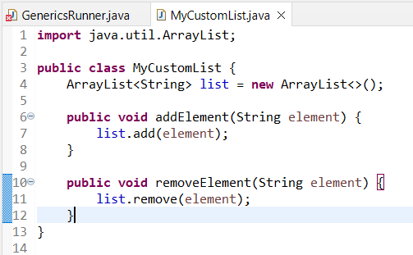

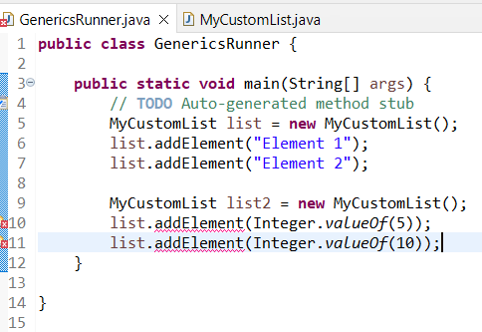

Using the above class, our class (MyCustomClass) is tied to a single data type, i.e. String. However, we want it to work with multiple classes like Integer, Character etc and for that we need to use generics. We can use generics with type (define it in a class) as follows.

**Generics with Type**

Wherever we had String, we change it to T in order to improve our functionality.

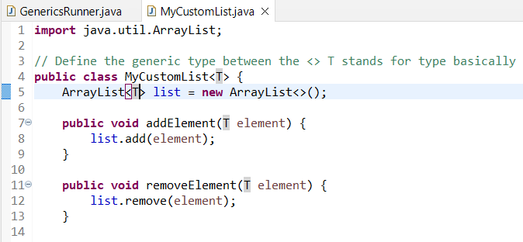

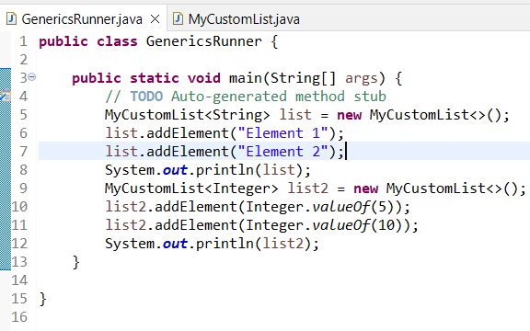

**With generics, once you specify the variable type on a class, wherever you'd typically specify a type, in all those places,**

<https://www.udemy.com/course/java-programming-tutorial-for-beginners/learn/lecture/9565788#overview>

**Using the following we can restrict the generics to prevent adding Strings.**

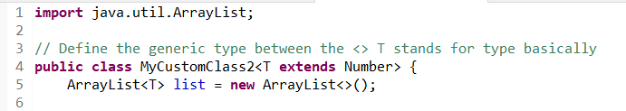

**Creating generics with methods**

The beauty of this method is the fact that in here, all the methods which are typically available in the List class are available. So, all the list methods are available. So, if you wanted to implement generic logic for any of the implementations of the list, I can do something of this kind. So, this is a very generic method.

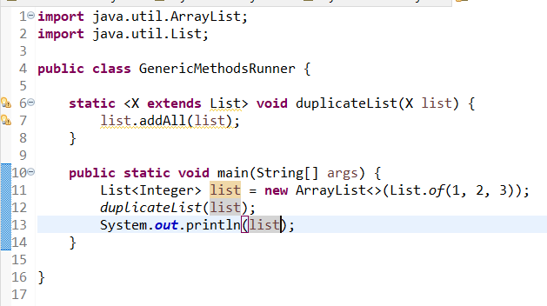

**WildCards (in method arguments/local variables/member variables)**

Method which can do the sum of any list of numbers.

This is able to add integers, double and long.

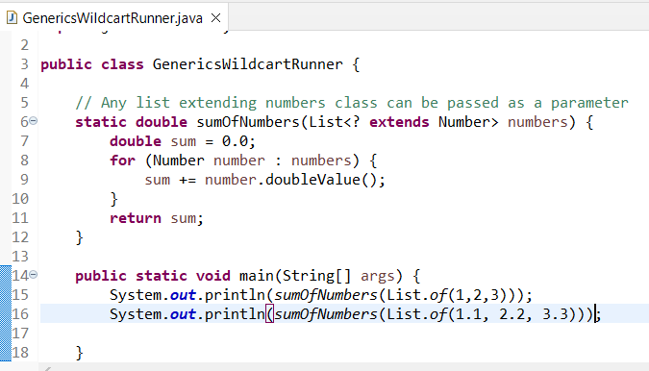

**Section 17: Functional Programming**

<https://www.udemy.com/course/java-programming-tutorial-for-beginners/learn/lecture/9565792#overview>

Its all about giving first class status to functions. Trying to create variables with functions, trying to pass functions to functions, and having return values as functions brings in a completely different thought process.

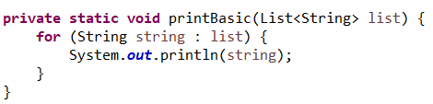

I'll call this printWithFP and in functional programming, the way you can do the same thing is by saying, list.stream. So, I'm taking all these elements in the list and I'm converting into a stream of values. So, this becomes a stream of values. So, first Apple would come, then Banana, then Cat, and Dog. So, list.stream().forEach(action); What do I want to do with forEach? You can see what action you want to do, action is nothing but method, right? What action do I want to do? What I want to do is, I would want to take each of the elements. So, I would want to take each of the elements and I would want to call System.out.println (elements); Now, focus on this syntax. So, after forEach after the parenthesis, I am pressing enter and I am pressing an enter after here as well, so that, you can actually focus on the syntax. So, what I'm saying here is, list.stream().forEach open parentheses, within the parentheses we are saying, element->, this is a specific syntax, this is called a lambda expression. We'll discuss that a little later. What we are saying is, for each element in this list, do a System.out.println(). This is nothing but logic, right? This is method code. So, I am saying for each element in the stream list, do a System.out.println() of element.

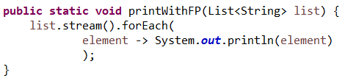

Instead of looping and telling what to do with each string, what we are doing is we are converting this into a stream, and we are calling forEach in it and we are passing what to do with each element. Another interesting thing in here is the fact that what are we sending to forEach? Is this data? Nope. This is not data. This is action. We are sending the code, we are sending for each element, execute this. We are sending a function code to forEach. We are actually sending a function to execute on each of the element in the stream, and we saw it being executed and printed in.

Hence, we are able to pass a function as a parameter to another function (forEach).

Now, lets change the logic to print elements ending with “at”.

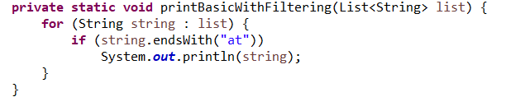

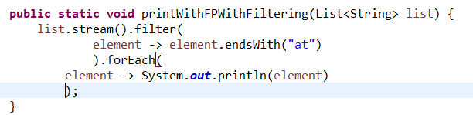

So, instead of looping around, we're talking in different terms in here. With functional programming, we are not trying to loop around and do a lot of stuff. All that we're trying to do is, we are telling what should you do with each element. We are saying here, first is, filter that element. So filter, what should be the filtering logic be? It should endsWith("at"), that's the filtering logic. Okay, what if it's ending with "at"? Okay, for each one of them, take it and print the element out.

Printing sum of a list of numbers

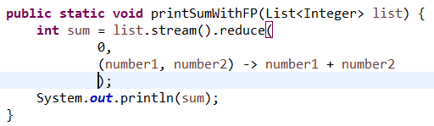

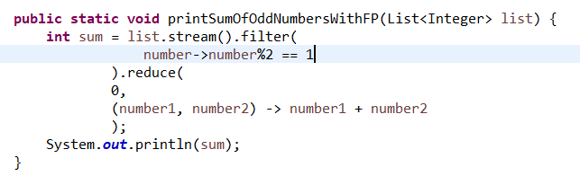

We are streaming numbers, we are filtering those which are odd numbers by calling the filter function and sending the logic to it and then, we are summing them up by using the reduce.

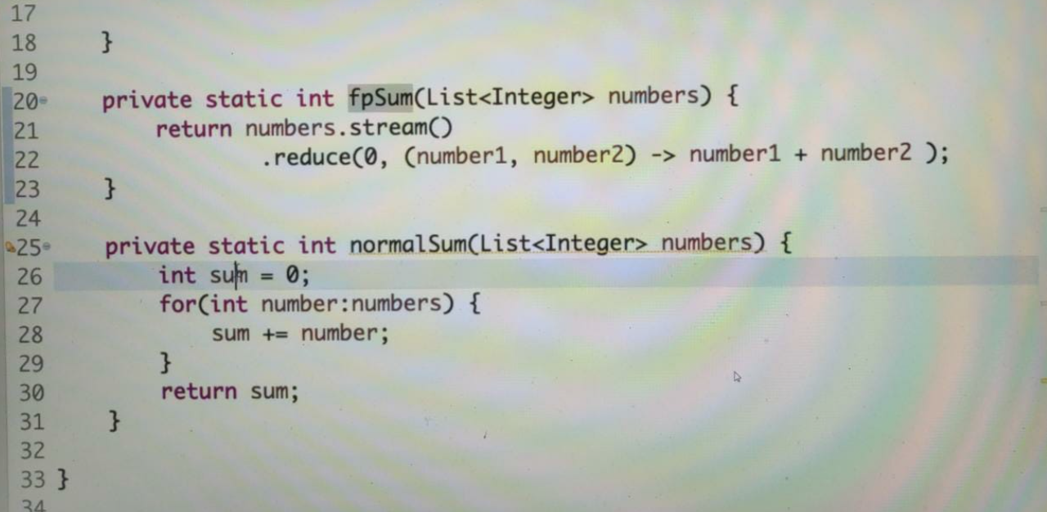

Think about it, spend some time thinking about whether you would like to write this kind of code or whether you'd like to have this kind of code. How is functional programming different, right? One of the major difference that you can see in here is, the value of the sum variable, right? So, the value of the sum variable is initially 0. And each time you loop around the number, the sum gets incremented. So, the value of sum is changing as you keep looping around this loop. This is called mutations. So, the value of sum is changing. Your program has mutations. Think about another thing, right? Here, we're saying exactly how to do the sum. So, we are saying, okay, initialize it to 0, we are saying loop around all the numbers, take each one and add it out, and then return that value back. With functional programming, we are not worrying about all that, we are saying okay, take a stream of numbers and for each one of them, add them up. So, what should I do with every pair of numbers? Add them up. That's the only thing I'm telling it, I'm not worrying about local variable, I'm not worrying about how to loop. So, I'm just saying what to do, add them up. Here, we are not just saying what to do, but we are also saying how to do it; create a local variable, add each number to it, store it into a temporary variable, and finally, return the value back. Two important differences between functional programming and typical procedural programming, in functional programming, we avoid mutation of variable. So, we don't really try to have variables whose values are changing.

The second thing is we focus on telling what to do. So, every pair of numbers, add them up. How many ever numbers are there, keep adding them up, that's what to do. We don't worry about how to do it. Here we are trying to tell how to do it. Take each number from the array, then add it to the previous calculated value of the sum, and at the end of the entire method, return the sum back. You don't need to do that with a functional programming. The idea behind this step was to compare the functional programming approach with the typical procedural approach that we follow.

*Until now, we learned that functional programming is all about giving first class status to functions. One of the parts of giving first class status to functions is allowing them to be passed as parameters to another method. We got our functional programming journey started with that in the previous steps and we also talked about the fact that with functional programming, we would not have any mutation of state, and we said functional programming focuses on telling what and not how to do it.*

**Basic Terminology**

1) Lambda Expression (shortcut way of writing a method): (num1,num2) -> num1 + num2

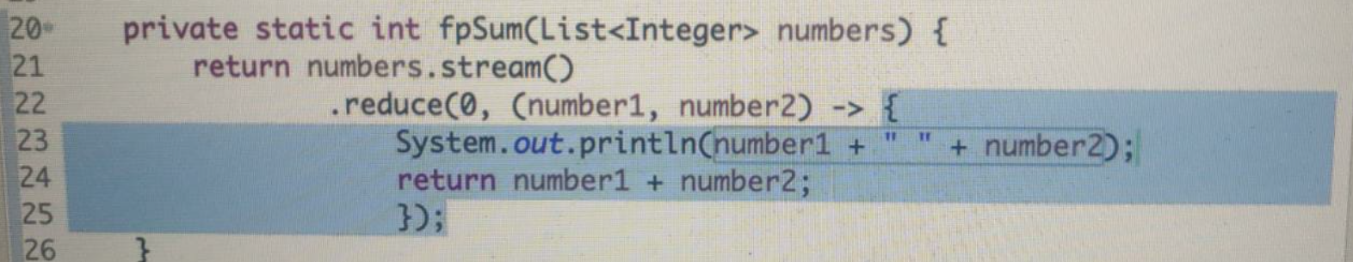

2) Stream: A stream is just a source of objects (Integer, String etc) and we perform intermediate operation (eg filter) which results in another stream of elements or we can perform terminal operation on it (eg foreach is used to printout the elements, reduce which gives a simple result back by reducing the number of elements).

So, the difference between an intermediate operation is the output of an intermediate operation is typically another stream, and the output of a terminal operation is either to consume the entire stream or to return one result back.

**Intermediate operations on streams**

1) Sorted: So, in the stream, there is a method called sorted which would take all the numbers, sort them, and then we are sending them to forEach to print it.

numbers.stream().sorted().forEach(element -> System.***out***.print(element + " "));

2) Distinct: Returns the distinct elements

numbers.stream().distinct().forEach(element -> System.***out***.print(element + " "));

We can also combine 2 intermediate operations:

numbers.stream().distinct().sorted().forEach(element -> System.***out***.print(element + " "));

3) Map: Mapping each element to its square

numbers.stream().map(e -> e * e).forEach(e -> System.***out***.println(e));

We can execute any number of intermediate operations on a stream but only a single terminal operation. So, at the end, the stream has to be consumed or reduced to one result, or reduced to a list or something of that kind. Once you have reduced it to a list, that's the end result. (None of this modifies the real List)

**Terminal Operations**

The result of a terminal operation on a stream is typically one value. It might be a sum of the numbers, it can be average of the numbers, or it can be minimum or maximum, or it can even be a list. So, there is one return value at the end of a terminal operation on a stream.

1) Adding all numbers in a list. Its taking a stream of values and converting it to a single number (hence it’s a terminal function).

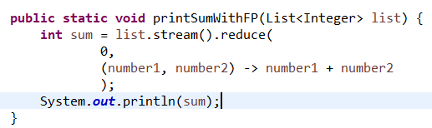

2) To get the max value in a list: (we are passing a comparator to max)

System.***out***.println((list.stream().max((num1, num2) -> Integer.*compare*(num1, num2))));

This returns an optional object (to avoid NULL) and hence we can use **.get()** on the optional object to get the value. To get min, just replace max with min.

3) Performing a terminal operation to get a list of odd values from a list of values.

List<Integer> newList = list.stream().filter(e -> e % 2 == 1).collect(Collectors.*toList*());

**Optional**

It is used to avoid null pointer exceptions.

Typically, when we are having a list of values and we are trying to process them, and at the end of it if there is no result, typically we return null back. And what could happen is the consumer of that API might not know that you are actually returning a null back. So, instead of using an object, you can actually use an optional as the return value.

System.***out***.println((list.stream().max((num1, num2) -> Integer.*compare*(num1, num2))));

This returns an optional object (to avoid NULL) and hence we can use **.get()** on the optional object to get the value.

**.isPresent()** is used to check if optional contains a value or null.

**.orElse(0)** can be used to assign a value incase the final result turns out to be null.

list.stream().max((num1, num2) -> Integer.*compare*(num1, num2)).orElse(0);

So, optional is just a way to avoid returning nulls. Whenever you are returning something which might exist or might not exist, then you can return a optional back, and that's what most of the methods in the streams do. Max might be there, might not be there; minimum might be there, might not be there. In all those kind of situations, streams return an optional back and then, you can use orElse to assign a default value or you can directly call a get if you're sure that there would be a value.

**Method References: Another functional programming concept**

<https://www.udemy.com/course/java-programming-tutorial-for-beginners/learn/lecture/9565826#overview>

list.stream().map(e -> e.length()).forEach(e -> System.***out***.println(e + " "));

list.stream().map(e -> e.length()).forEach(System.***out***::println); // method reference (shortcut for the above)

Each element is passed to this method and executed. Not only static methods, but also instance method calls can be replaced by a method reference.

list.stream().map(String::length).forEach(System.***out***::println); // method reference (shortcut for the above)

For the string instance, the length method is being called.

<https://www.udemy.com/course/java-programming-tutorial-for-beginners/learn/lecture/9565828#overview>

<https://www.udemy.com/course/java-programming-tutorial-for-beginners/learn/lecture/9565830#overview>

Summary…





Now, this functional programming concepts open up a lot of new avenues for programmers. It enables us to write code which does not use mutation. Before functional programming, the only way to do sum of numbers would have been something of this kind. But with functional programming, you can go one level up. You can go from imperative style of programming; this is imperative style of programming because I'm exactly telling what to do and how to do it as well. In imperative style, we not only tell, okay I would want to find out the sum of all integers. Nope, you are saying okay, create a variable called sum each time add it up and then return it back. That's imperative style. Functional programming allows a declarative style of programming. You just tell what to do. For every two numbers, every pair of numbers, add them up and return it back. Functional programming allows you to program at a level up, at one level up than what we usually do.

**Section 18: Threads and Concurrency in Java**

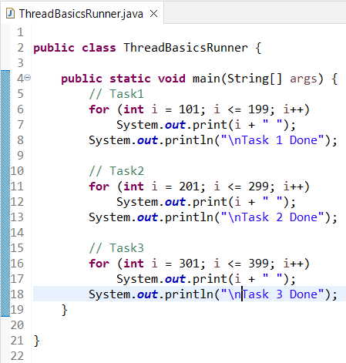

So, the main method completed execution. So, when we run this, we would be able to see everything going in, right. So, you have Task1, that's completed, Task 2 is completed, 201 to something, and task, next Task3 is done and you have main done.

This is typical programming. What is happening is, all the things in the Task1 are done and after that Task2 and after that Task3, right. This is normal programming stuff, right. Until now, whatever code that we wrote, runs. After the execution of this line, we would go into the next line. So, inside a method, first these lines are executed, then the next ones and then the next ones and then the next ones. Over here, we have three different tasks, right. So, Task1, Task2, Task3. Typically, in a lot of scenarios, you might have situations where Task1, Task2, and Task3 are independent of each other and some of these tasks might be dependent on external services. Probably you are depending on I/O and a lot of that kind of stuff. So, during the execution of this task, your CPU will not be fully utilized. But, even then, the CPU has only one task to execute. So, what it would do? It would keep waiting. So, even though we can execute Task2 in parallel with Task1, the CPU does not know that. So, what it would do? It would keep waiting. Threads allow you to run all these tasks in parallel. So, you can have one thread running this code, another thread running this code, and another thread running this code. So, all these three tasks can be run in parallel. Parallelism, you can actually increase the utilization of your CPU, because while it waits for data from an external service or a database, it can keep processing the instructions from the other tasks. In the next step, we would start with creating a Thread and try and parallelize Task1.

**Creating A Thread**

1) Extending Thread class

2) Implementing Runnable interface

Using method 1:

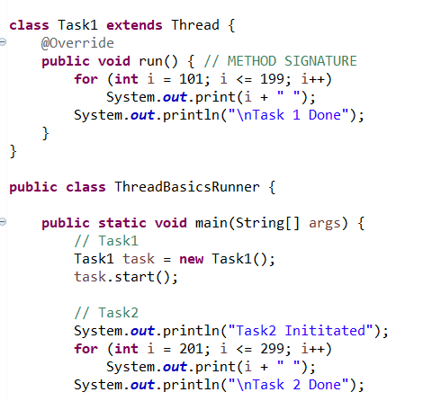



If I call the method task.run() then it behaves like a regular method. task.start() will kick it off as a thread and hence execution takes place alongside task 2 as we can see.

Using method 2:

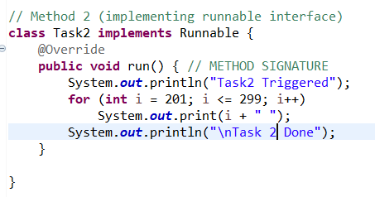

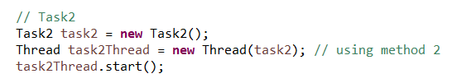

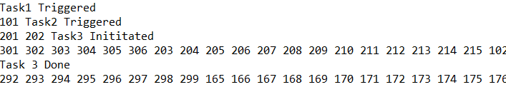

Since now task2 is also threaded, task3 is triggered before task2 gets completed (unlike previously when only task1 was threaded, task 2 had to be fully completed before task3 could begin).

Let's say, these are three different threads which are doing three different activities. Then by doing them in parallel, we get a lot of benefits because now we are making optimal use of our CPU. We are keeping it busy even when it's waiting for something for Task1 or Task2 or Task3. It has other tasks it can do. That's the biggest advantage of going for threads.

The five states of a Thread are **New**, when the Thread is created. However, the start method is not really called. After calling the start method, a Thread might be in any of these three states: Runnable, Running, or Blocked. **Runnable** is when I am ready to run. However, some other Thread is running at this point. **Running** is when I am the one which is running. So, my state would be Running. **Blocked** is when I am calling an external interface or a database or something like that and I'm waiting on it or I need some data from some other Thread which has not yet completed execution. So, that's the state when I am blocked. The last state is **Terminated or Dead**, when I have completed execution. These are all the different states that a Thread can be in.

**Giving priority to threads**

In the thread class we can use a method **setPriority()** to set priority on a specific task (which is used to change the priority of a thread).

Min priority = 1 and max priority = 10.

When I say a thread has priority 10, it's just a request. It does not mean that always that thread would get the highest priority. It's just a hint. The request might be honoured or might not be honoured as well.

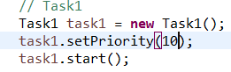

In the output, sometimes task1 is completed before task2, sometimes after and many other cases.

**Join**

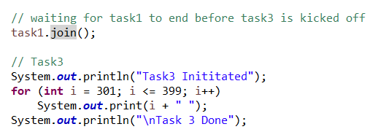

task1.join() waits for this thread (task1) to die/complete.

This is very important when, before picking Task3, I would want to make sure that Task1 is complete.

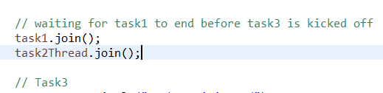

The advantage of doing stuff in this way is, because now, I've kicked off Task1 and Task2. So, both of them are running in parallel and I am waiting for both of them to complete execution and after that we are kicking off the other tasks.

**Thread utility services**

1) Thread.sleep(): sleep is a static method on the thread class which makes it sleep for a given amount of miliseconds (sleep means in the wait state).

2) Thread.yield(): yield is a static method in the thread class. There might be situations where I think, okay, I'm getting a lot of CPU. I don't want lot of CPU. At this point, I'm okay to go into a waiting state, right. So, Thread.yield( ) is kind of that. So, it's a request.

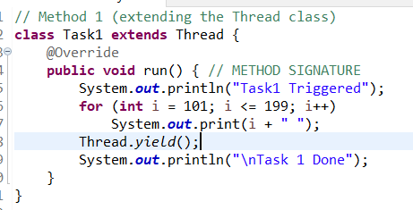

3) Synchronized keyword: Let's open up the code for one of the Collection classes. Let's open up the code for HashTable. As you can see in here, HashTable is available from Java 1 and this approach of synchronization is also available from Java 1. You can see that over here, most of the methods have a synchronized keyword. So, synchronized, synchronized, synchronized. So, almost every method in the HashTable has a synchronized keyword. Now you might be wondering why the HashTable is synchronized. Let's say there is a piece of data. Let's say there is a piece of data that is shared between these two Threads. Let's say, these two Threads share an instance of a HashTable. When you put a synchronized on here, then only one of these two Threads, either the Task1 or the Task2, only one of these Threads will be able to execute the code in any of the synchronized methods. What I mean to say is if there are 50 synchronized methods, at any point in time, only one of these Threads would be able to execute any of the 50 synchronized methods. You have 50 synchronized methods. Let's say they have 1000 lines of synchronized code and only one of the Threads would be able to execute any of these 1000 lines of code. If one Thread is already executing any of these 1000 lines of code, then the other Thread has to wait for the first Thread to complete execution of the synchronized code and come out of it before it can get access to execute the method. That is the importance of the synchronized keyword. One of the important things to understand is synchronization would put a lot of overhead because these 1000 lines of code will be executed only by one Thread at a time and it would make all the other Threads, which needs to execute that code, wait for it. So, the performance of the system might get affected. In recent versions of Java, like Java 5, Java 8, there are more alternatives to enable Thread safety. We are not just dependent on the synchronized approach. When we talk about concurrent Collections, we would talk about other approaches to Thread safety.

**Executer Service**

Executor Service provides facilities to do all the things that we have talked until now. It helps us to kick off multiple Threads at the same time. It helps us to monitor the state of these Threads and it helps us to write logic which enables us to say, okay, if either Thread1 or Thread2 or Thread3 has completed, then that's fine. I would want to take the result of whichever one has completed first. Or, you can even say something like, okay, wait until all the Threads have completed execution in a single statement. So, that's all the kind of code that you would be able to do with an Executor Service.

1) Single thread

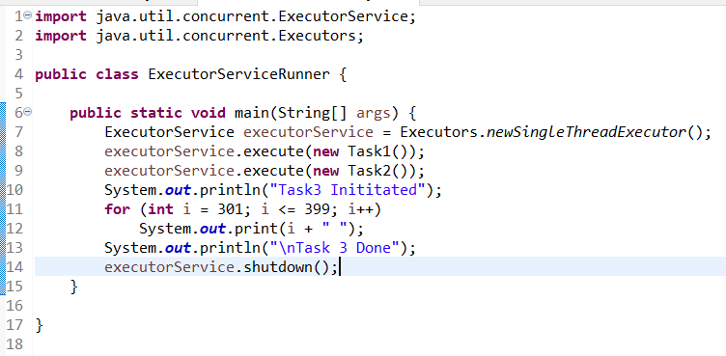

What this SingleThreadExecutor does is, it provides facilities to execute one Thread at a time. So, at a particular point in time, this ExecutorService would be able to run only one Thread.

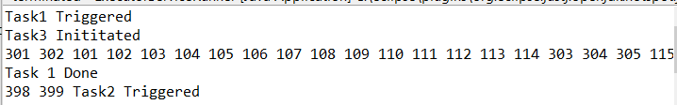

Now, you can see, Task1 has started, Task3 has started. So, Task3 has completed and only after Task1 has completed, Task2 has begun and executed. So, in the executorService, what we are executing are only two, right. So, we are executing the Task1 and Task2 in the executorService. Task3 is executing in the main method. So, it's not executed by the executorService. The ExecutorService at any point in time, because we are using a newSingleThreadExecutor, can only execute one task. So, when Task1 started executing, only when Task1 has completed execution, Task2 would be executed and that's exactly what we are seeing in here. So, Task1 started and only when it's completed execution, Task2 has started and completed execution, right.

**.showDown()** is used to shutdown the executorService once the tasks are completed else it keeps running.

2) Multiple threads

ExecutorService executorService = Executors.*newFixedThreadPool*(2);

3) Returning a future from thread using callable

<https://www.udemy.com/course/java-programming-tutorial-for-beginners/learn/lecture/9565858#overview>

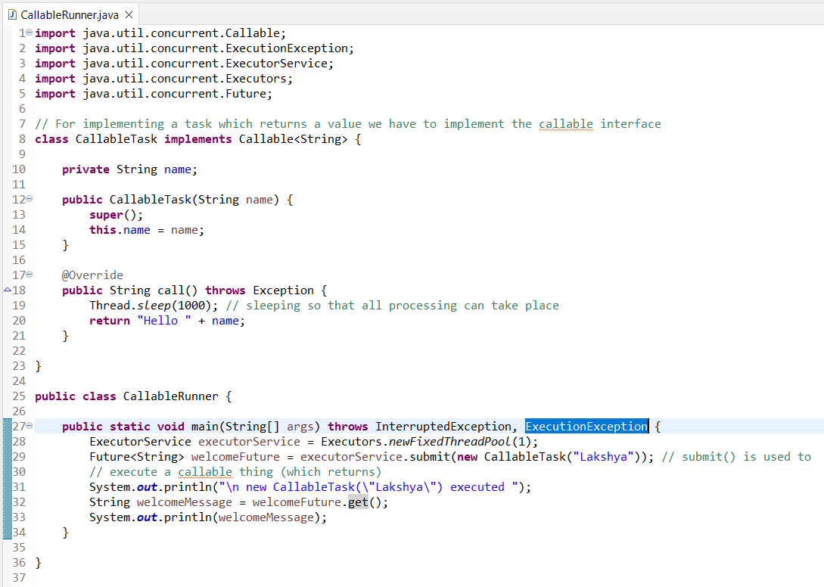

One of the important things that the get( ) method does is on a Future, you can call a get( ) method. Future is not really a result, it's a promise that there will be a result. Once I call a get() method on the Future, then this would wait for the task to complete execution. So, only after completing the task, the next line would be executed. Future is a promise that we will have the result at a later point in time and when you do get( ) method on the Future, then we are waiting for the result. So, only when the CallableTask completes execution and when we get the result back, the rest of the code would be executed (sysout welcome message will be executed after we get a message).

**Submit multiple tasks and wait for all of them to complete**

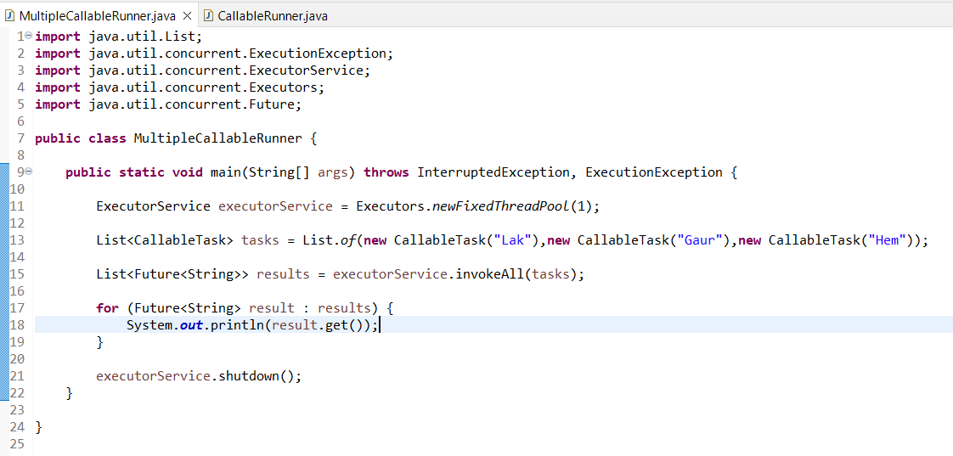

Line 13: Creating a list of tasks.

Line 15: Now, what I can do is, to the ExecutorService, there is a method called .invokeAll( ) and to this, you can pass in a Collection. So, what I'll do is, I'll pass in tasks to it. What it would do is it would invoke all the tasks and what it would return is not just one Future. It would return a list of Futures, List<Future<String>>. So, when we execute all this tasks, what we will get is a List of results back. So, we'll get all the results back. In here what the invokeAll( ) does is, it would wait for all the tasks to complete execution and then get the results and put them in to this List. So, only after all the three tasks completes execution, the results would be printed.

So, you can see that this code is much much more easier to read and use. If you want this to go further, faster, I can say newFixedThreadPool(3), what would happen? It would actually use three Threads. So, you would see that it would run even more faster. So, you can see that this run happened much more faster than earlier, because now we have three Threads where this code is running it.

**Waiting for any 1 task to complete execution**

Just before this we saw how to execute multiple tasks and wait for all of them to complete execution. However, some of the times you would want to wait for only one of them to complete execution and take the result of the one which completes first and ExecutorService also allows us to do that.

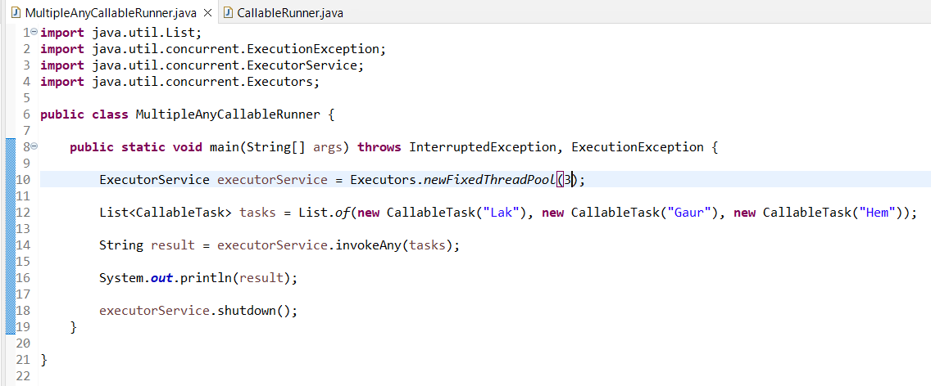

So, what invokeAny( ) does is, it would wait for any of these tasks to complete. So, if one of the tasks completes, it gets the result. So, the result is just one result. What we are doing in here is very simple, right. We are kicking off three tasks. Whichever one completes, we are taking that result and we are printing that out. So, if there are three services that you are using and you want to give your customer the fastest result, then you would just take the first one and return it back. In those kind of situations, invokeAny( ) is very, very useful.

You can see that the result changes. Because we have three threads and three tasks that are assigned, you'd see that each time I run it, there might be a different result, right.

You can pass multiple list of tasks and as soon as one of these task completes execution, it returns the result and we can use the result. That's the use of the invokeAny( )

**MultiThreading is always a very, very interesting concept because we always want to do things fast, we would want to run as many task as possible in parallel. So, you'd want to create a number of Threads to process this task and that's where ExecutorService makes things very, very easy.**

**Section 20: Files and Directories in Java**

**Recursively Listing files and directories**

**package** files;

**import** java.io.IOException;

**import** java.nio.file.Files;

**import** java.nio.file.Path;

**import** java.nio.file.Paths;

**import** java.nio.file.attribute.BasicFileAttributes;

**import** java.util.function.BiPredicate;

**import** java.util.function.Predicate;

**public** **class** DirectoryScanRunner {

**public** **static** **void** main(String[] args) **throws** IOException {

Files.*list*(Paths.*get*(".")).forEach(System.***out***::println); // list all the files and directories present inside the root directory (not recursive)

System.***out***.println();

Files.*walk*(Paths.*get*("."), 2).forEach(System.***out***::println); // to go deeper we use walk() and type numbers

System.***out***.println();

Predicate<? **super** Path> predicate = path -> String.*valueOf*(path).contains(".java");

Files.*walk*(Paths.*get*("."), 4).filter(path -> String.*valueOf*(path).contains(".java"))

.forEach(System.***out***::println); // walking through a directory and matching files containing java

System.***out***.println();

Path currentDirectory = Paths.*get*(".");

BiPredicate<Path, BasicFileAttributes> javaMatcher = (path, attributes) -> String.*valueOf*(path)

.contains(".java");

BiPredicate<Path, BasicFileAttributes> directoryMatcher = (path, attributes) -> attributes.isDirectory();

Files.*find*(currentDirectory, 4, javaMatcher).forEach(System.***out***::println);

Files.*find*(currentDirectory, 4, directoryMatcher).forEach(System.***out***::println);

}

}

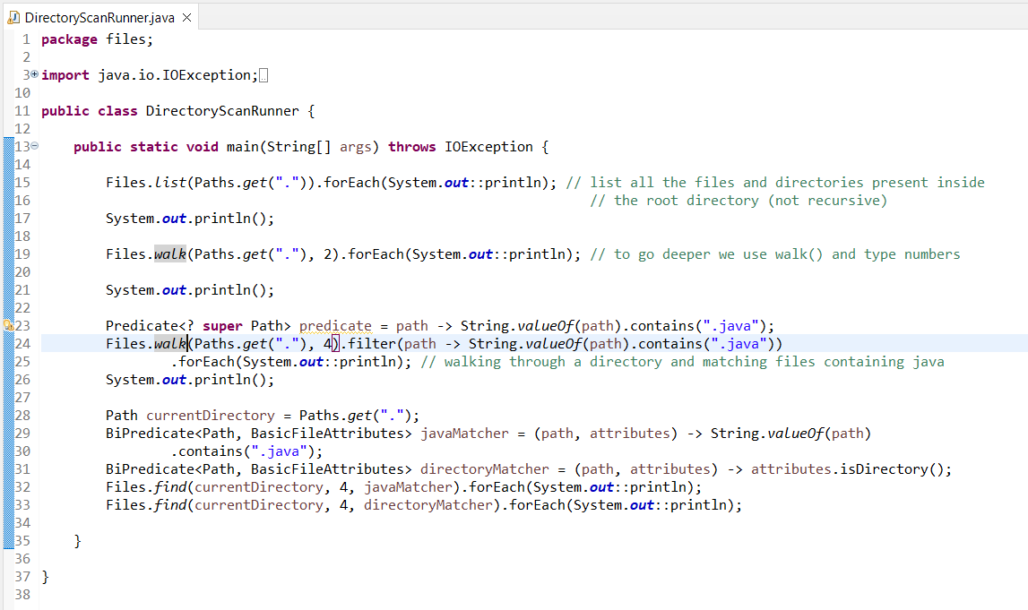

We started with using the walk( ) method to look through the directories and print the Java files. The predicate that the walk offered was just providing us with the path. So, what we did was we did String.valueOf(path) and checked if it contained (".java") to filter the values. But, the find( ) method provides us much more better filter. So, the predicate defines both the Path and a few BasicFileAttributes. So, you can filter based on the name of the file and the path, as well as you can filter based on certain characteristics of the file. Here, we are using the directoryMatcher.

**Reading contents from a file**

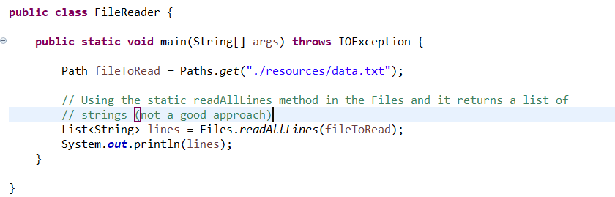



Is this a good approach to do this? Let's say your file has a million lines of code or million lines of text in there. Do you want to read them all at once and print them all at once? What would happen? Everything gets readed into the memory at once. So, all the million lines which are present are scanned and put into memory at the same time. That might not be a good thing to do in most of the situations, unless your files are very small.



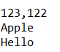

Files.lines() does not read all the lines at once, it would give you a Stream of each of the lines. Now, I can use the Stream to process them. So, I can say forEach, This would not actually try and read the entire file at once, this would take one line, process it one line, process it one line, process it, and so on. So, that's why this is much more efficient when you have a lot of things to do and the other important thing about this is you can now say filter/map.



**Writing to a File**

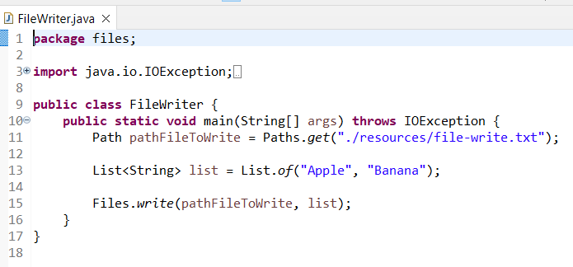

**Section 19: Exception Handling**

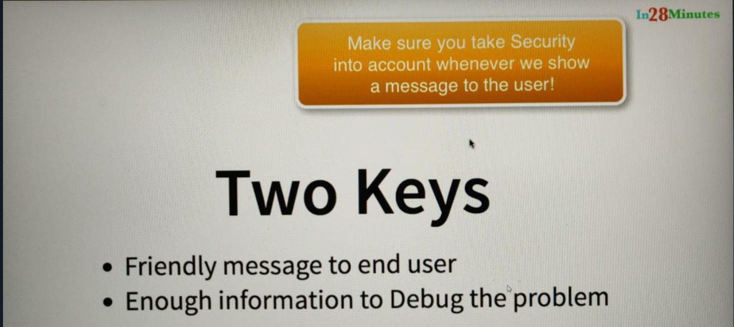



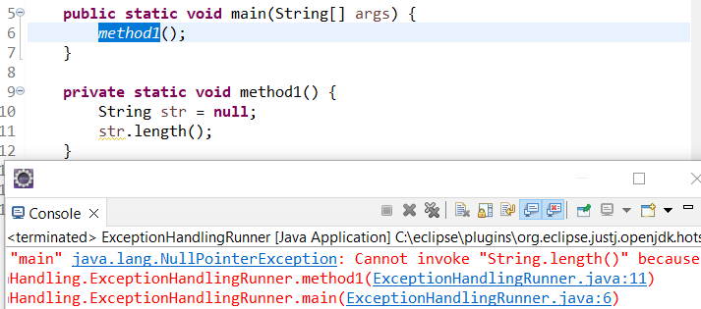

The above is a stack trace which shows the line which caused the error and what is the error.

If an exception is thrown and it is not handled then it would be thrown up and the subsequent lines wont be executed.

If a method is unable to handle an exception, then the method calling it will try to handle the exception and if it is not able to handle it then its subsequent code will also not be executed.

In the following we have used try, catch in method2 to handle the exception and hence method1 and main doesn’t even know about the exception since its being handled by method2 and hence the subsequent lines of main and method1 can execute.

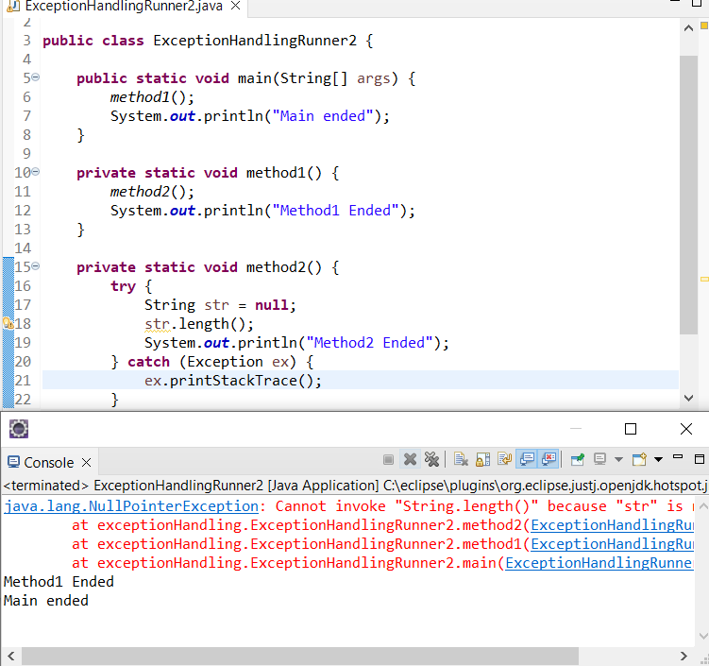

So, method2 is causing the exception and method2 handled it. So, method1 will not know about the exception at all, it would think okay, method2 did something right and it would go ahead and execute the next line of code, and the flow shifts once the method1 completes execution, it goes to Main Ended . The only thing which we are doing is, we are also printing this stack trace to the output because we would we want somebody who is looking at it to know that there was an exception that happened, it will not cause the program to fail, but whoever is looking at the log will know that there was something wrong that happened.

So, you put all the code that you'd want, put exception handling around in a try and do the exception handling in the catch block. We also realized that once you throw an exception, the line after that, the code after that will not be executed because this method2 ended was not really printed to the console.

The other thing we understood was, if an exception is handled in a method, then the exception is not visible to the calling methods. So, because method2 handle the exception, the method1 and main did not know about the fact that there was an exception. So, they continued executing the next lines of code.

Exceptions have a hierarchy aswell. A NullPointerException extends RunTimeException which in turn extends Exception (subclasses). What happened in here was, this code was throwing a NullPointerException. The NullPointerException matched the catch block with the exception because NullPointerException is a subclass of Exception, it's in the tree of exceptions under Exception. So, when a specific exception happens, the catch block which is the most specific one, so, NullPointerException happen and NullPointerException matched, that is the one which is executed. So, the two things are: one, you can have multiple catch blocks, you can have different strategies to handle different kinds of exceptions. When an exception happens, the most specific of those exceptions is the one that matches.

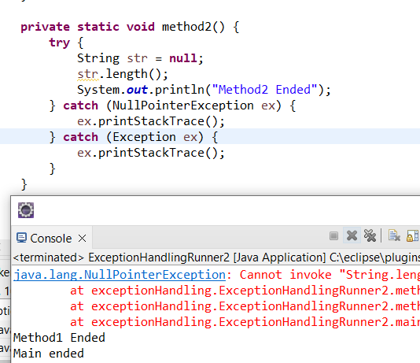

We learn that there is a hierarchy in the exceptions as well. NullPointerException is a subclass of Exception, ArrayIndexOutOfBoundsException is another subclass of Exception. We also learnt that, if an exception happens and even though there is a exception handling for some other exception, it will not match that. So, if an ArrayIndexOutOfBoundsException occurs and if there is an exception handling only for a NullPointerException, then the exception handling will not be executed. For an exception to be matched, it should be at least that exception or a superclass of that exception. For example, if it's ArrayBoundIndexOutOfBoundsException, it should be either ArrayIndexOuOfBoundsException, the catch should either be ArrayIndexOutOfBoundsException, or a IndexOutOfBoundsException, or a RuntimeException or a Exception. One of these catch blocks would match, cool.

**Finally**

If we execute the following code then exception is not handled and hence is thrown and that’s the reason scanner.close() is not executed. If this happens a lot of time then memory leaks will take place and hence we use **finally** to help with the closing of such objects.

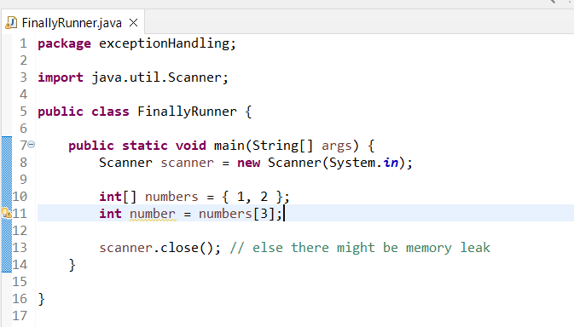

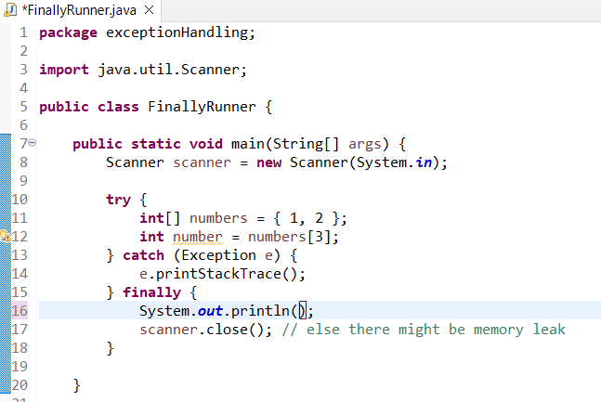

So, what is happening in here is, this code in finally is always executed. So, even if there is an exception or if there is no exception, this code is executed. We learnt about finally. We want to make sure that all the objects that are created are closed before we go out. And that's what finally helps us to do. It helps us to execute some code irrespective of whether an exception happens or not.

Watch the below video (4minutes only) for various concepts/puzzles related to finally

<https://www.udemy.com/course/java-programming-tutorial-for-beginners/learn/lecture/9565876#overview>

**Checked vs Unchecked Exception**

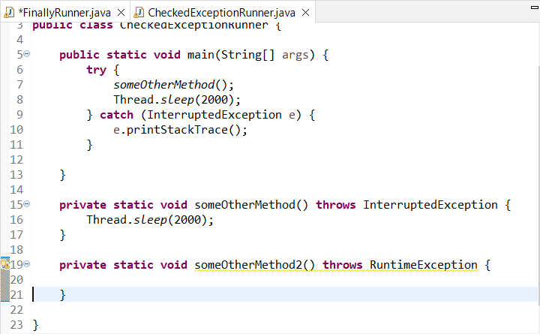

Certain methods are risky and they tell that, I am risky by saying I will throw an exception. So, some methods throw RuntimeException, some method might be throwing InterruptedException, some methods like Thread.sleep would throw InterruptedException as well. There are a lot of other methods in Java which says, I'm going to throw an exception, I am risky. Sometimes, some of these exceptions force you to handle it. The way you can handle that is by either having a try catch block or by declaring that I would throw the same exception. The question is, which kind of exceptions force you to handle it and which kinds of exceptions you can ignore. (eg someOtherMethod will force us to handle the InterruptedException using try catch in the main whereas, someOtherMethod2 wont)

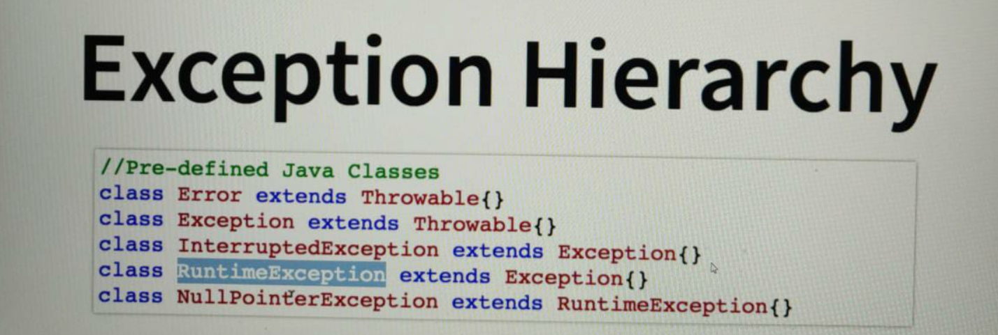

The most important things that you would need to take out of this specific step is the fact that, there is an exception hierarchy and at the top of the exception hierarchy is a class called Throwable. There are two important things which extend Throwable; Error and Exception. Errors you cannot do anything about stack overflow or out of memory. Make sure that you don't create them. There is no way you can handle them. The things which you can handle are exceptions and there are two kinds of exceptions, those which are RuntimeException and subclass of RuntimeException and those which are not Runtime Exception and those are called checked exceptions. RuntimeException is an unchecked exception, any subclass of RuntimeException is an unchecked exception. If a method throws a checked exception, then the calling method should either handle it or throw it. If a method throws a RuntimeException, then the calling method need not do anything about it.

*Until now, we discussed how to handle exceptions which somebody else has thrown, something which was in the Java API and things like that. Now, let's focus on throwing exceptions in our code. How do we throw exceptions from our code. In this step, let's focus on throwing a very simple exception from our code.*

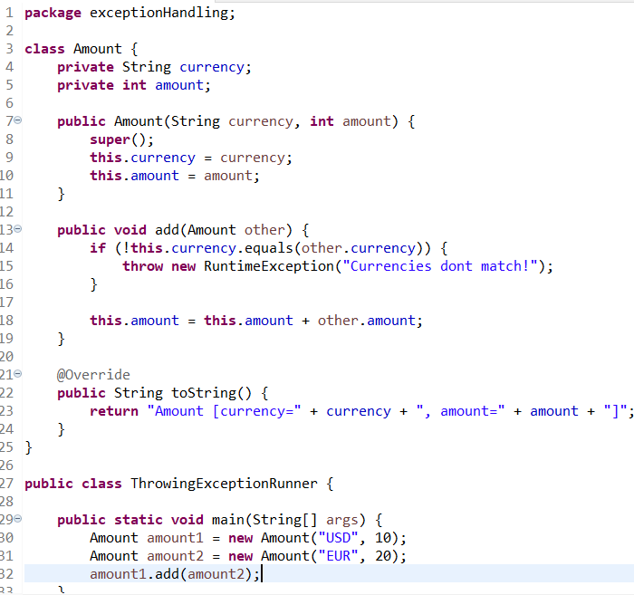

In the above code the user cannot add two different currencies. However, we are able to throw a **RuntimeException** and not an **Exception**. The reason is that whenever we try to throw a non RuntimeException (basically whenever we try to throw a checked exception) our method needs to tell that in our signature using **throws exception** and when I accept that throws in the main method, it has 2 options; either use a try catch block or throw an exception itself.

If you throw an unchecked exception, you don't need to worry about throwing that exception out. But if you're throwing a checked exception, then you need to say throws and whoever is calling you, needs to either handle it or say throws.

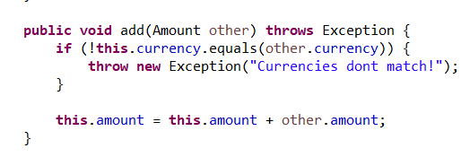

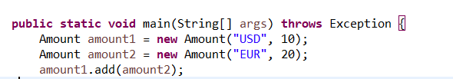

**Throwing a custom exception**

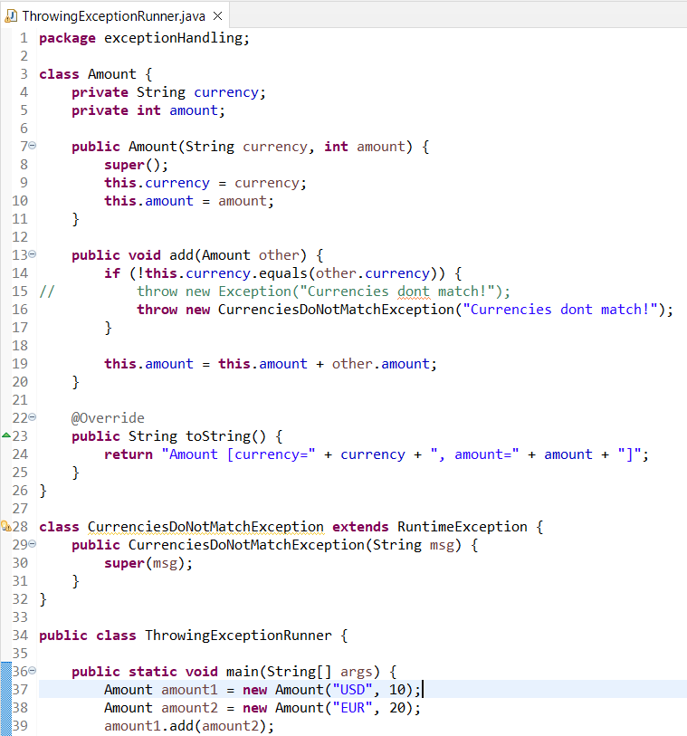

**Try with resources**

Whenever you are doing things which would need to be closed, typically, this is the new way of doing it. So, one of the important things is, this scanner implements a class called Autocloseable. So, if you look at this closeable, it implements something called, it extends something called Autocloseable. Anything which implements the interface Autocloseable, we can use it in the TryWithResources. You can see that in the Autocloseable, there is a method called Close. What this does is, if some error happens in the code, then the close is called on this specific variable. So, you don't need to explicitly make the call to the close. This helps us in making our try catch blocks much more simpler. In the code of the try with resources, you can focus on reading the input and things like that and don't really worry about how to do the exception management.

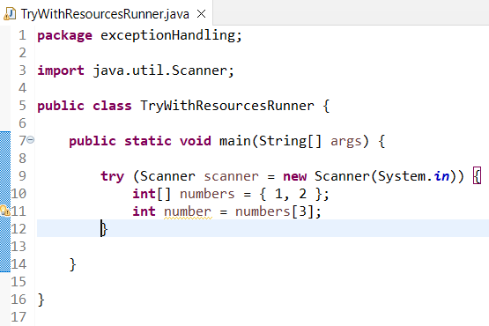

To handle multiple exceptions in the same block:

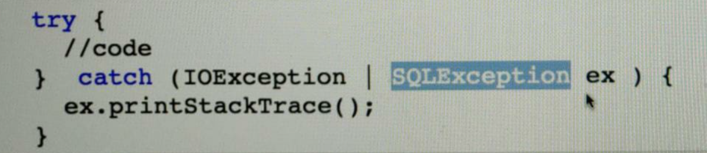

The following code will not compile. CurrenciesDoNotMatchException is a subclass of exception. So, your catch blocks should always be in the hierarchy starting from the subclasses to the super classes. So, the hierarchy should be CurrenciesDoNotMatch Exception and then RuntimeException, and then exception. So, if you don't have a RuntimeException then, the way it should be is the catch block for Currencies DoNotMatchException first, and then, you should have the catch block for exception. So, the order of these catch block is not right.

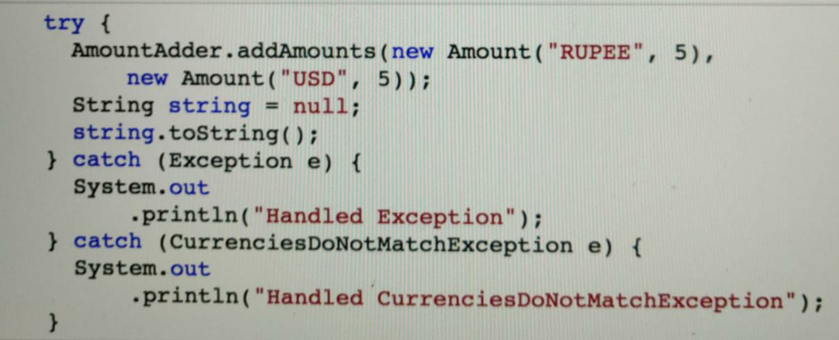

**Section 21: Concurrency and Concurrent Collections**

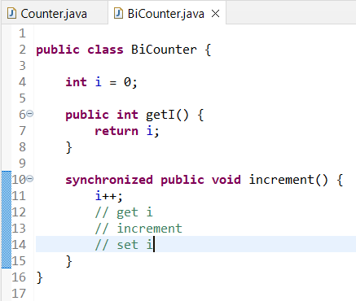

I++ is not atomic.

Now, one of the things that you would need to realize is i++ looks like a very very simple operation, right. But actually, when we look at it in depth, it's involving three operations. What are those three operations? The first thing is to get the value of i, increment, and the third one is to set the value of i. Now, let's say, this counter is shared between five threads. What would happen if, let's say, two of them are trying to do the increment method and the first one has done the getI( ) and the second one also also has getI( ). So, let's say, the current value of i is 15, right. So, the current value of i was 15, the first thread did a getI( ). So, it gets, what does the value Thread1 gets? It gets 15. The second thread also at the same point did a getI( ). So, what does it get? 15. The first thread increments it. So, what does the value become? 16 and it sets it to i. So, the value of i at this point would be 16. Now, the other thread now has the value of i as 15, so it would increment it as 16 and it would set the value of i as 16. So, even though two threads have done the increment, from 15, the value should go to 17. But what would be the value in i? It would be 16. So, the thing is i++ is not really a thread-safe operation. In the sense that, if I am executing the same method at multiple threads, there is a chance that some of the updates might be missed. This is called not thread-safe. Thread-safety is when a method can be safely run by multiple Threads at the same time. However, this method is not thread-safe because there is a chance that an update to i might be lost and that's where we talked about synchronized.

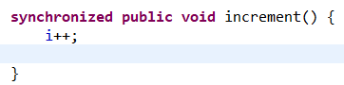

So, if you put a keyword called synchronized, then only one thread at a point in time would be running this specific method. So, if there are two threads trying to run this method, the first one is starting to execute this and then the second one has to wait for this specific thing.

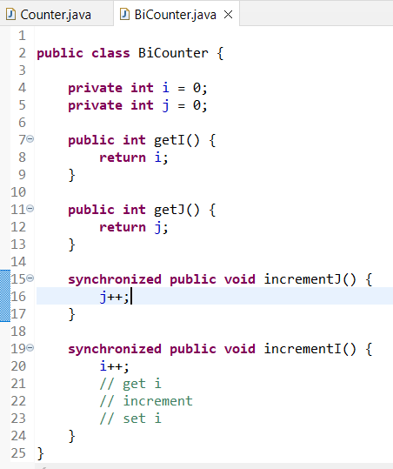

What is the problem with this approach? I have two methods which are synchronized: incrementI( ), incrementJ( ), both these methods are synchronized. What is the problem with synchronizing both of them? Only one thread can be executing any of these synchronized methods. So, there might be one thread waiting for incrementI( ), the other thread waiting for incrementJ( ), even though these two operations are completely different. So, i++ will not affect j++ at all, only one thread would be allowed to execute either of these methods. This is the case when there are two methods. Imagine if there are 10, 15 synchronized methods which are present in there and there are a lot of threads waiting to be executing those methods. This would have a significant performance impact. Basically, the problem with synchronization using synchronized, is the fact that only one thread can be executing all the synchronized code on an instance. So, if there is a lot of synchronized code on a specific instance, it would have significant performance impact. Lets see a solution.

**Locks**

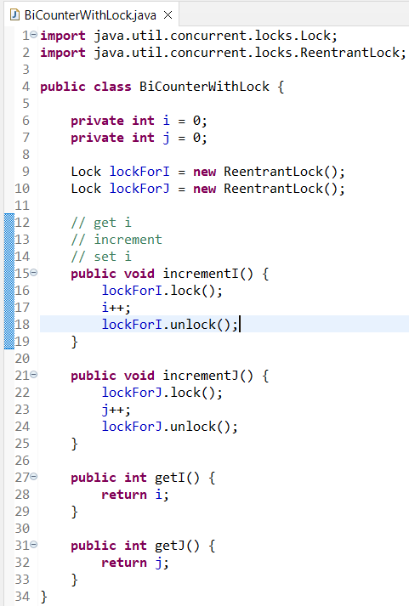

The thing with locks is, instead of having one big synchronized chunk of code, we are breaking it up into multiple small chunks of synchronized code. So, a thread can be executing incrementJ() and in parallel another thread might be executing incrementI() as well. That is the flexibility that locks provide.

lockForI.lock( ), lockForI.unlock( ), and that would allow us to make this code synchronize or make this code thread-safe, without going in for synchronized.

*One of the important reasons why we had to have the locks is because this is not an atomic operation. This involves three steps, and that's the reason why we cannot do i++, and depend on it being thread- safe, right. What if there are more thread-safe operations? What if there are classes that are providing those thread-safe operations? That's where the idea for atomic classes comes into picture. Let's look at a few of the atomic classes.*

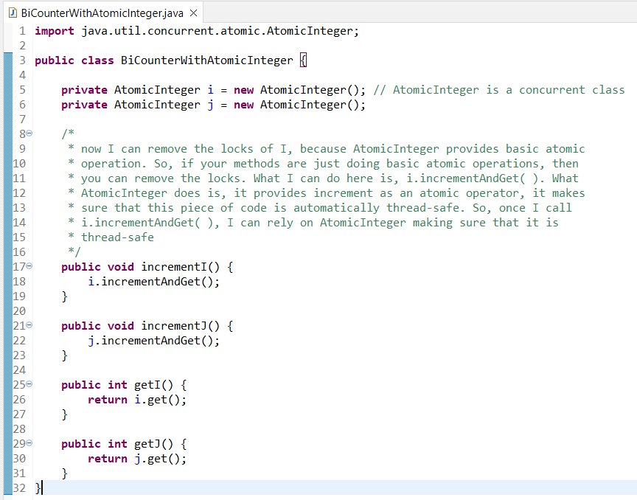

However, you need to understand that this approach will not work for everything. The fact is, we are doing a simple increment and that's why AtomicInteger is good. But, there might be multiple steps in your operation which might need thread-safety and in those kind of situations you have to go with a lock. But, in this situation because it was a simple operation, we go with an AtomicInteger.

**Section 22: Java Tips**

One of the best practices in Java is, whenever you do an import, import a specific class. Don't use something like a * which is used in here, because that's not a good practice. Typically, the good practice is to import all the specific classes.

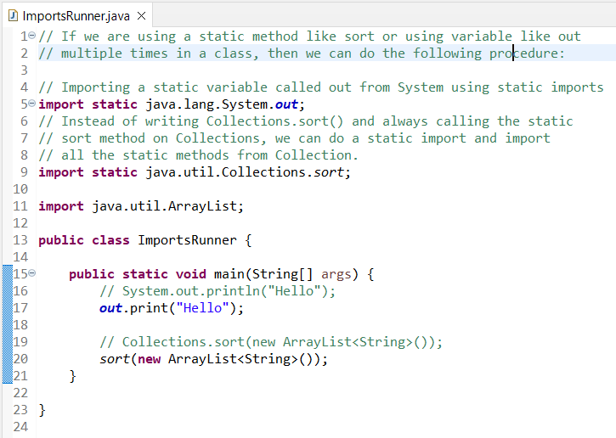

The default implementation for the equals method is provided by the Object class and it says that unless both of the references/pointer refer to the same object in memory, they are computed to be not equal. By default, the equals method in the Object class compares them to be equal only if they are the same object.

However, we can override the equals method within the class.

Commented is the reason why we are comparing **if(getClass() != obj.getClass())**

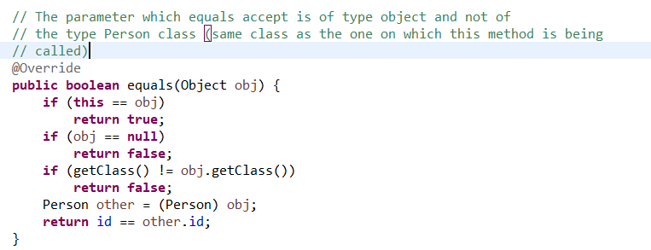

The important takeaways from this specific video are, one, whenever you implement a equals( ) method, you should also implement a hashCode( ) method. Your hashCode( ) method should distribute the objects evenly among the different buckets. That's the most important thing about a hashCode( ) method and the two properties which a hashCode( ) method should always satisfy are; if two objects are equal, then their hashCodes should also be equal and also hashCode should not change unless the values of the object changes.

**Access Modifiers (public, protected, (default), private)**

These actually help you to decide what kind of things in your class are accessible to people who write code outside your class.

**Class Access modifiers**

A **public** class can be used by classes in other packages as well.

If we don’t mention any access modifier then by default the class is only visible inside the same package (or its subpackages).

We cannot make a class protected or private.

**Method Access modifiers**

Inside the same class we can access (when the main method is inside the class itself) we can access all the methods.

Inside the same package (when the main method is outside the class) we cannot access the private methods.

Inside different packages we can only access the public methods. (not the other 3)

If you declare any method as public, it is available everywhere. So, wherever you can access the Example Class, you can access the publicMethod( ), whether it's the same package, different package, anywhere, you'd be able to access it. Protected, on the other hand, can only be used either in the same package or in sub classes. So, if another class extends ExampleClass, then you'd be able to use the protectedMethod( ) in there. Private methods are only available inside that specific class, nowhere else. Default methods are available only inside that class and the same package. If you go outside that package, even if you inherit, you'll not have the default methods available.

A good understanding of all these is important because when you create your classes, you'd need to decide, what kind of things you would want other classes to access.

So, you'd always need to think about, okay, what are the things my sub classes need to be able to access? You need to make them protected. What are the things every class needs to access? Okay, those things I would make them as public. All the other things you should make them private. This would ensure that your class is properly encapsulated. One of the important things is, whatever discussion that we had about methods is equally applicable to variables. However, you don't really want to make any of your variables public. Unless those are final variables which are not going to change in value, all the other variables should remain private most of the time. You should allow access to these private variables through methods of various access levels: protected or public.

**Final Classes and Final Methods**

**final class FinalClass {}**

Now we cannot inherit or extend this class.

Why do you want to make a class final? Good question. Let's look at String class. So, I'm opening up the String class, Control Shift T/Command Shift T or opening up the String. You can see that String is a final. So, in Java, String is a final class. You can look at the wrapper class Integer. It is also a final class. That means nobody would be able to extend String, Integer, Long, or any of that kind of wrapper classes. Now, why why is it important that you make a class final? Whenever you think you don't want to allow extension of your specific class, you don't want somebody to extend the functionality in your class, and modify the behavior of your class. One of the important things to realize is that whenever somebody extends your class, they have the privilege of modifying some of the code of your methods and that might not be something you'd want to allow in certain situations.

**final public void method();** this will make this method file and all the classes inheriting this wont be able to override this method.

**Final Variables and Final Arguments**

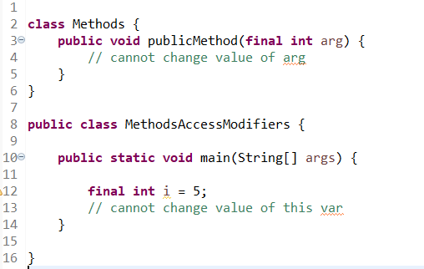

Final is recommended on all variables and all arguments. Typically, you should assign values to variables only once and you should assign values to arguments only once. You should not keep modifying the values of variables. This is called immutable programming and that's recommended because it leads to code which is easily understandable. That's why you'd see coding standards, lot of coding standards recommend okay, every variable should be final and if you don't use final on a variable, it would come up as a coding standard violation. While it is not possible to have every variable as final, at least attempt to have most of the variables as final, where you would only assign values to them once.

**Static Keyword**

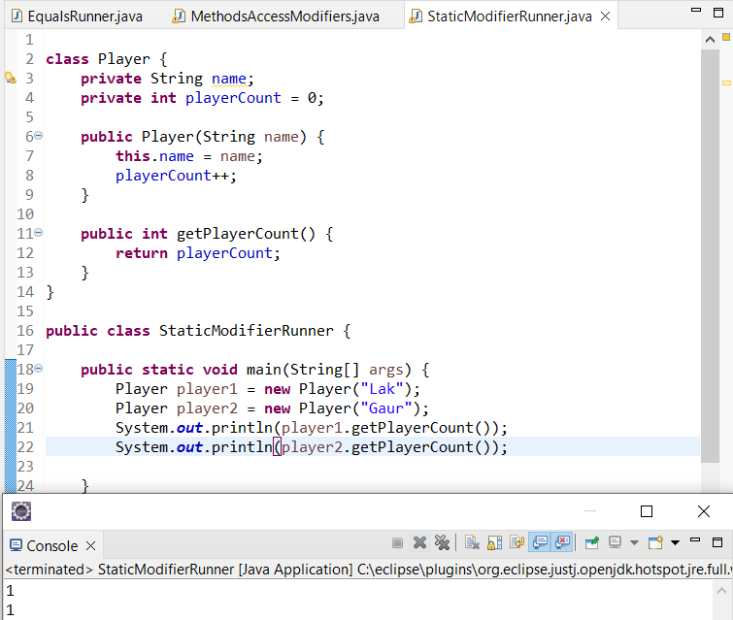

In the above case since both the objects have a separate value for the playerCount variable (separate instances of this variable) and that’s the reason why we get 1 as the playerCount. However, we don’t want this variable to have separate instances for different instances (objects) of this class and that’s the reason we need to use **static variables.**

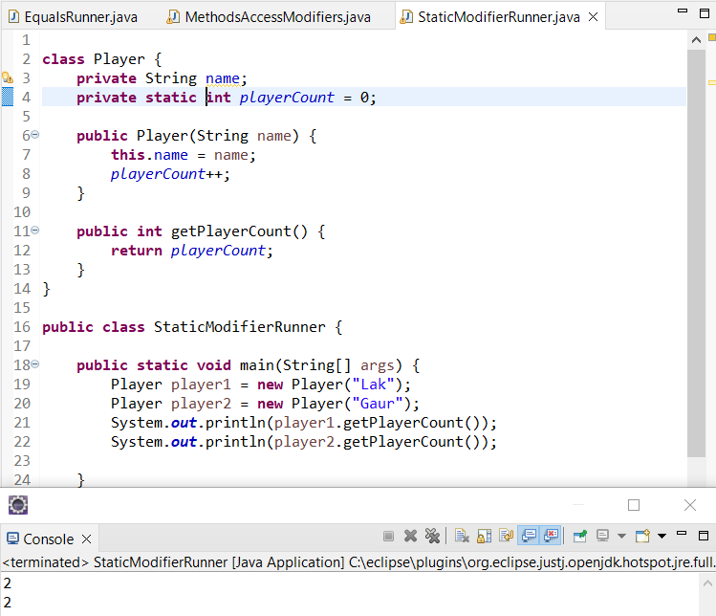

So, the count variable is shared between multiple instances of the player objects. It's not going to be one instance per object. It's only going to be a common shared one across all instances of the Player class. In these kinds of situations, we would go for using a static variable.

**Hence, we use static variables to share the same data/instance between all objects. We don’t want 1 instance per object but rather a shared instance for all objects.**

So, earlier we said player1.getCount( ). Think about it. Is count belonging to player1 or does it belong to Player class, right? So, will player1 have a different count from player2? Not really, right. So, player1 and player2 would have the same count because it's the shared instance between all the instances of Player. They'll have the same value for the count. Then why should I access it using player1. getCount( ) and player2.getCount( )? Why can't I access it through the Player itself? So, instead of player1.getCount( ), can I say Player. getCount( ), Player.getCount( ), right? So, that's what static methods enable us to do. So, I can say static in here, static public int getCount( ), this method in here is only accessing a static variable. So, you can call it static and now you'd see that the thing compiles and let's run this. A static method is something which is shared between all instances of that specific class. So, even though I have multiple instances of this class, there will be only one instance of the count and this getCount( ) method is shared between all of them. Static methods can also be called by instances (objects) but its not recommended.

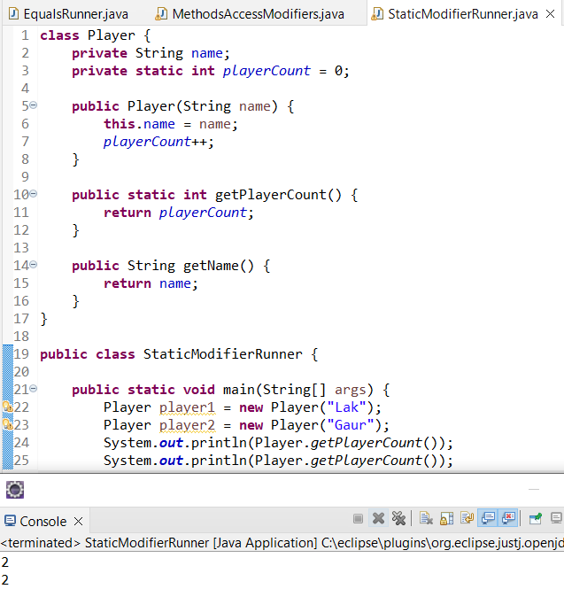

Rules around static variables

**getName() is an instance method, getPlayerCount() is a static/class method, name is an instance/member variable (unique per object) & playerCount is a class variable (shared among all instances).**

Static methods can only access static variables and call static methods (inside class level method, i.e. static method, we cannot access the instance properties).

Instance methods can access both static variables and non- static variables.

**In case of constant values its best to make them static final.**

**Nested classes: Inner classes and Static Nested Classes**

Any class nested inside another class is called as a nested class.

There are 2 types of nested classes:

1) Inner classes: non-static nested class.

2) Static nested class: nested class with a static keyword.

An inner class instance cannot exist/created without an instance of the enclosing class and that’s why we have to first create an instance of the enclosing class and then we can create an instance of the inner class. That’s the reason why we are able to access variables of the enclosing class in the Inner class because we know that when we create an instance of the inner class, an instance of the enclosing class is already created and hence I can access the value. However, we cannot do this in a static nested class.

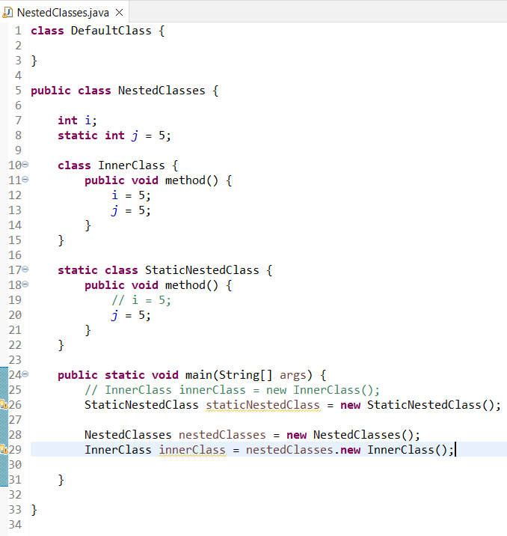

Nested classes are those classes which are inside another class. The entire declaration of the class is inside another class. A non-static nested class is called a inner class and an inner class cannot exist without the enclosing class instance. So, an enclosing class instance is needed to be able to create instances of the inner class. Therefore, in the inner class methods, you can access variables which are declared inside the nested class. A StaticNestedClass, on the other hand, is a static thing. So, it can exist without an instance of the enclosing class. You can directly create an instance of the StaticNestedClass and use it as if it's a separate class on its own. However, inside a StaticNestedClass, you cannot access the member variables of the enclosing class.

**Anonymous Classes**

So, what we are doing in here is, instead of creating a new class and doing everything, we are actually directly implementing the comparator in here. So, we are directly writing the code for the comparator in here and directly creating an instance of it. This way of creating a class is called an anonymous class because this class does not have a name. So, let's run this, animal [Cat, Ball, Elephant]. This class does not really have any name at all. You can actually right-click, Refactor, make sure that you are selecting the right way, and you can say, Extract Local Variable and say, lengthComparator. You can see that this is creating a instance. So, here we are creating an instance called lengthComparator. But there is no class, this class does not have a name. The instance of the class has a name, but this class does not have a name. Any class that does not have a name is called a anonymous class.

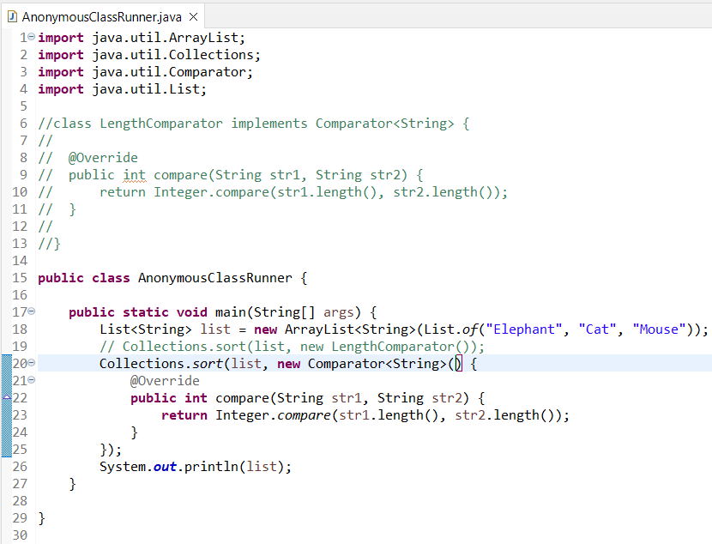

So typically, we create anonymous classes because we think, for example, this comparator which we are creating in here, the lengthComparator, I will not use anywhere else. In those kind of situations, it's unnecessary ceremony to create a class, put it somewhere, and maintain it. Instead of that, I can directly create it, where I would want to, and use it.

**Enums**

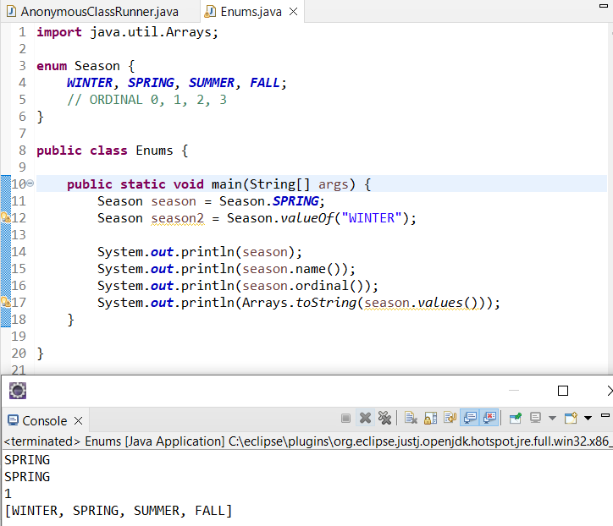

Enums can have variables, constructors and methods. It is not good to store values using the ordinal in a database since shifting their positions will change their ordinal and hence we use the following method to assign a specific value to an enum and we can use this value to store it in a database:

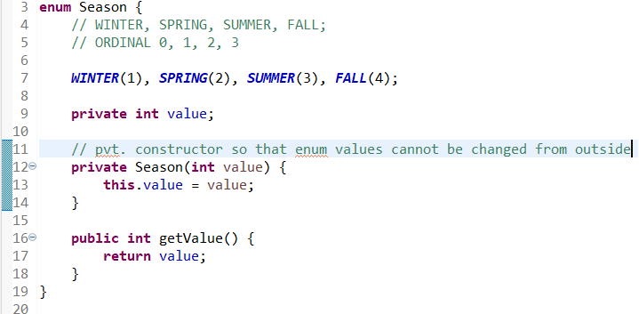

**So, whenever you think there is a specific list of values and you'd want to stick to those set of values, try and go for a enum.**

**Section 24: Java new features**

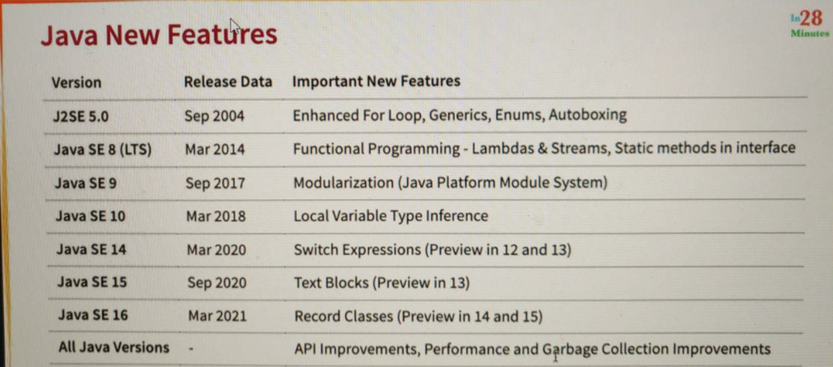

<https://www.udemy.com/course/java-programming-tutorial-for-beginners/learn/lecture/25694190#questions/16233428>

After following the above link we can see that I'm able to make use of desalting util and also use the sorting algorithm from the other project, Modulation three consumer that you can see that even if we create separate Java projects and use glass, but there is no way I can prevent the consumer from not using the algorithm statically in the next step. Let's start playing with modularization and see how modularization provides you with a solution.

<https://www.udemy.com/course/java-programming-tutorial-for-beginners/learn/lecture/25694188#overview>

<https://www.udemy.com/course/java-programming-tutorial-for-beginners/learn/lecture/25694186#overview>

**copyOf()**

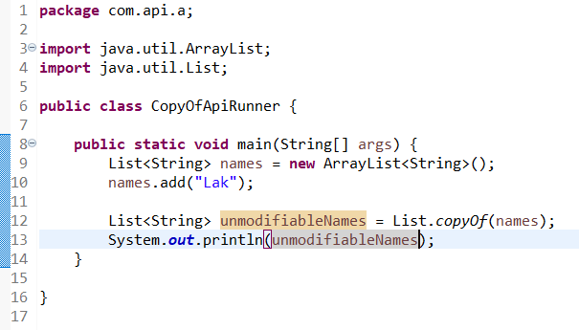

So whenever you'd want to create an immutable list of values from an existing list, you can use the list dot copy of method. Similar methods also set, maps. The great thing is that if we already pass an unmodifiable map then copyOf() method wont create a new map and it will return back the same exact map because it knows its unmodifiable already.

**readString and writeString methods**

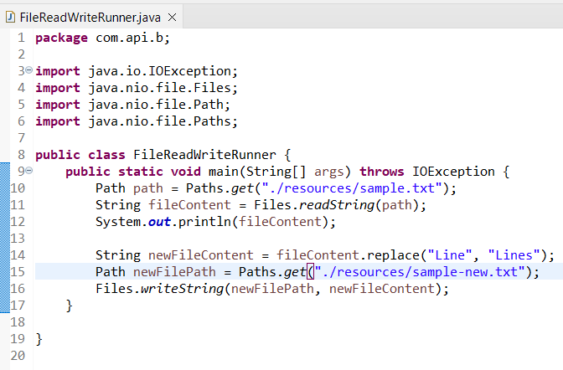

**Predicate not method**

The negate method is present on the predicate itself and here its used to print the odd numbers.

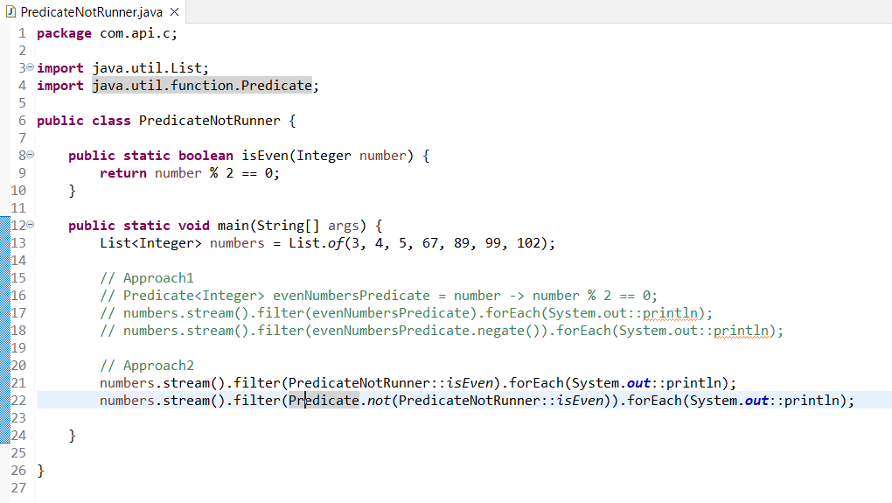

**String Utility Methods**

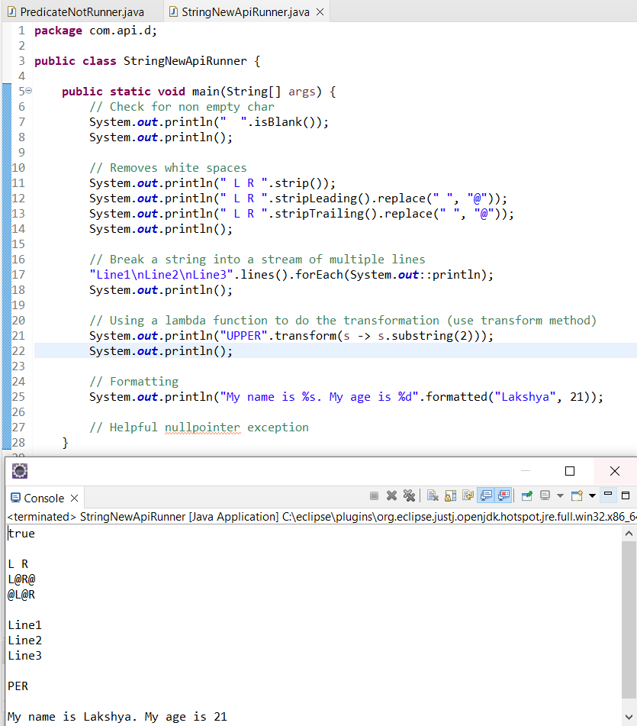

**Type References**

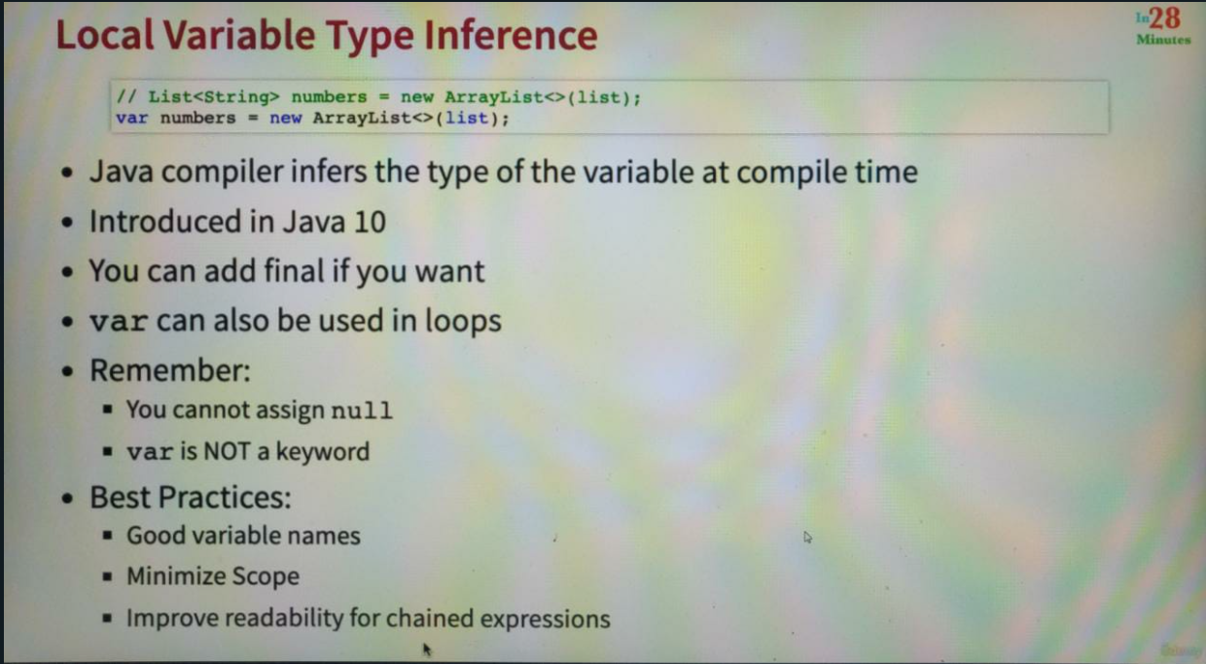

**Switch Expressions**

Allows us to create expressions using the switch statement.

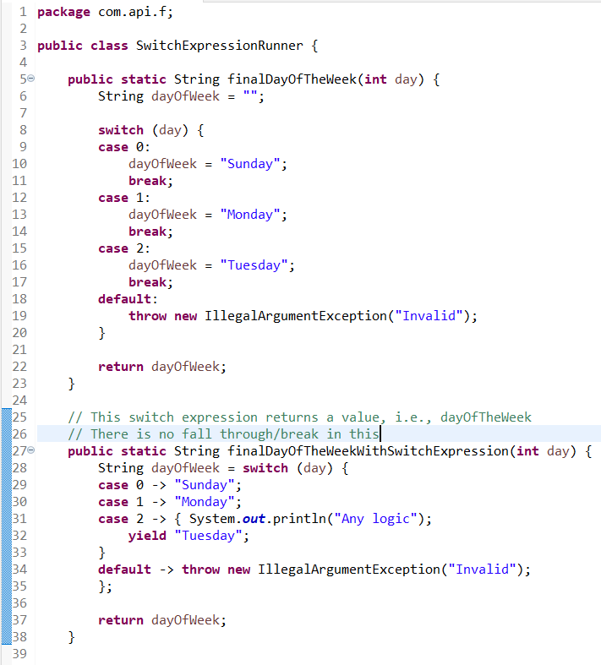

**Text Blocks**

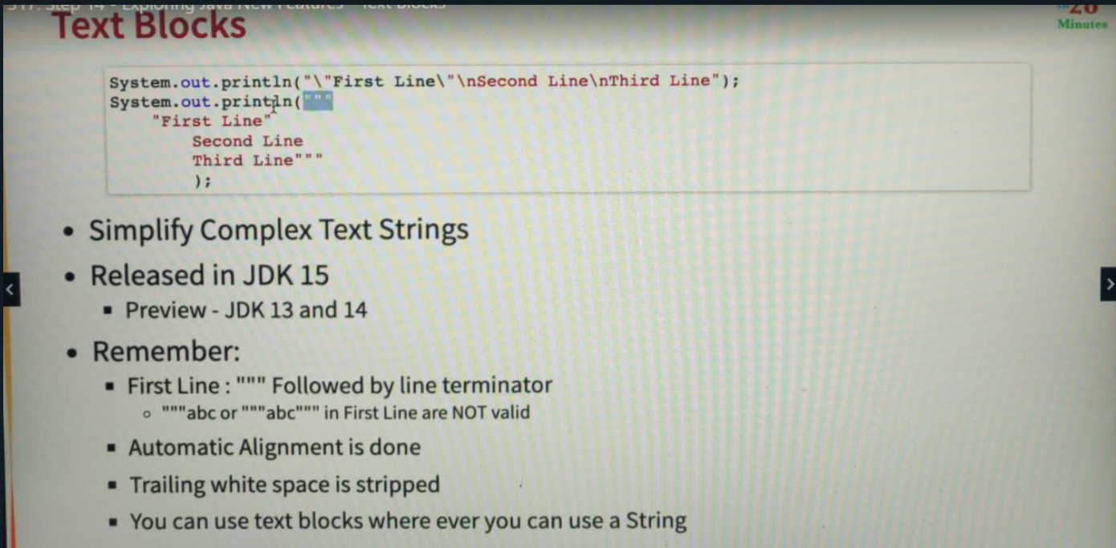

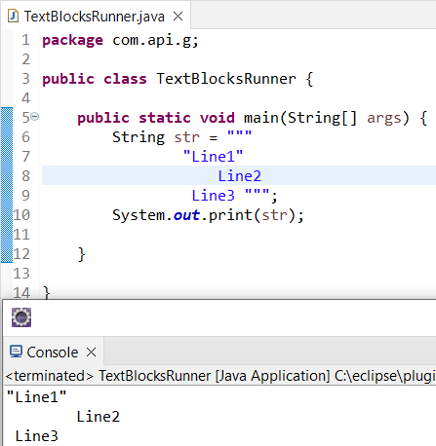

**Records**

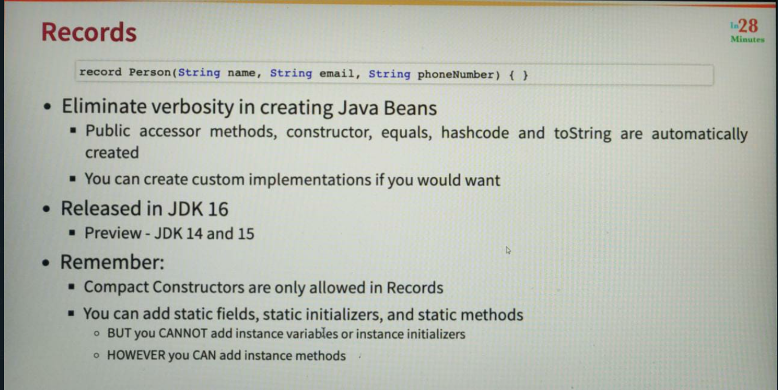

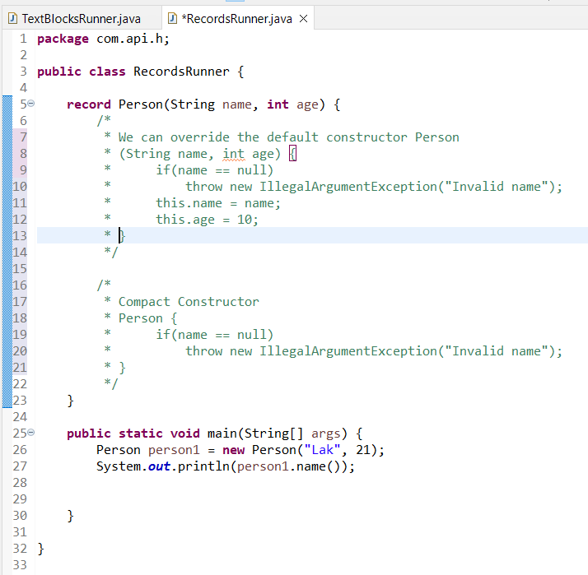

**Section 25: Spring Framework**

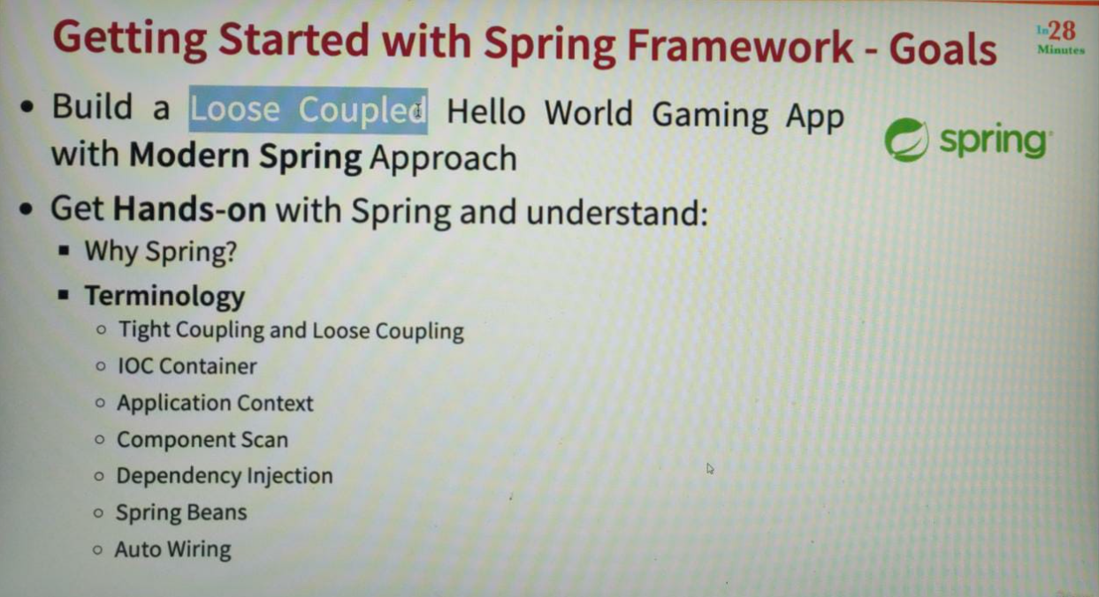

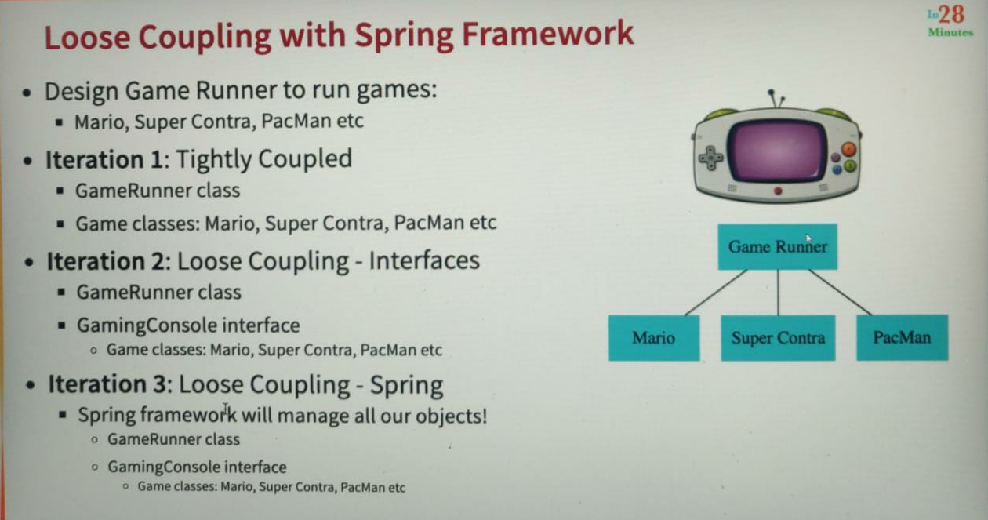

1) Tightly Coupled Code

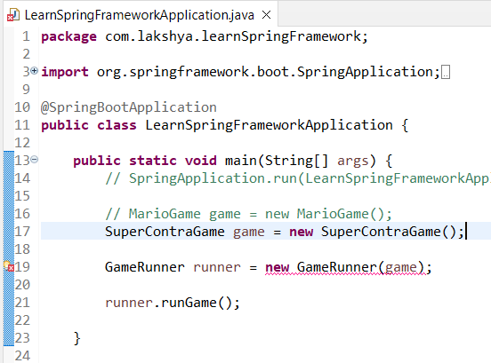

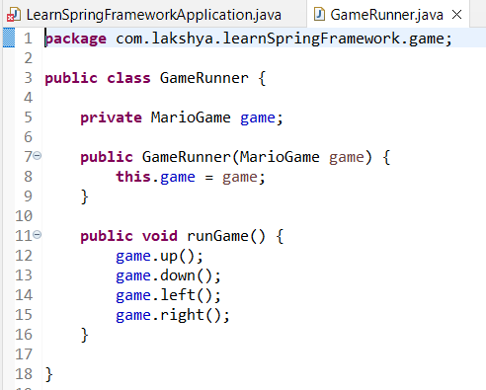

Currently, whenever I need to play a new game, I will have to change my gameRunner class accordingly which makes it tightly coupled to a particular game.

2) Loose coupling level 1 using interfaces

Here we are able to switch from mario to superContra game without making any changes to the game runner class In the GameRunner we are now switching it to use the gaming console, whichever implementation you provide in here, the game runner can make use of that where you are creating a Mario game or a Superman or a Batman game. The game, I can run it. That's the magic of interfaces. And now you can see that if I go to the application class, I'll be able to run super control game without making any changes. So GameRunner class is loosely coupled to whichever game it's running that because we are using interface.

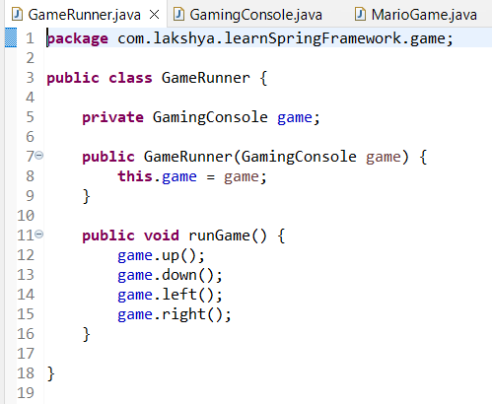

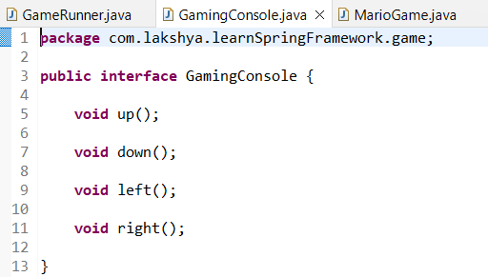

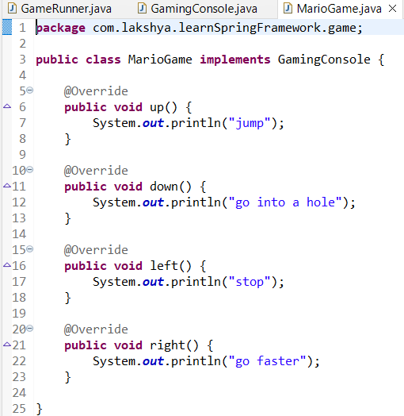

One of the things that you are seeing in here is the creation of the Mario game, the creation of the super contra game, and then the creation of the game runner is all done through Java Code. Typically, whenever you're talking about enterprise applications, enterprise applications have thousands of classes. Instead of manually creating objects, can we delegate the creation of objects to spring framework? Can we have this framework manage the creation and the lifecycle of the objects that we are creating in here? What we want to do is to make this spring framework to create the Mario game, and we would want to create a GameRunner class with the Mario game as a constructor argument. And then we want to call runGame(). Let's see how we can add this framework to do that in this specific step.

3) Loose Coupling Level 2 using spring

<https://www.udemy.com/course/java-programming-tutorial-for-beginners/learn/lecture/25694154#overview>

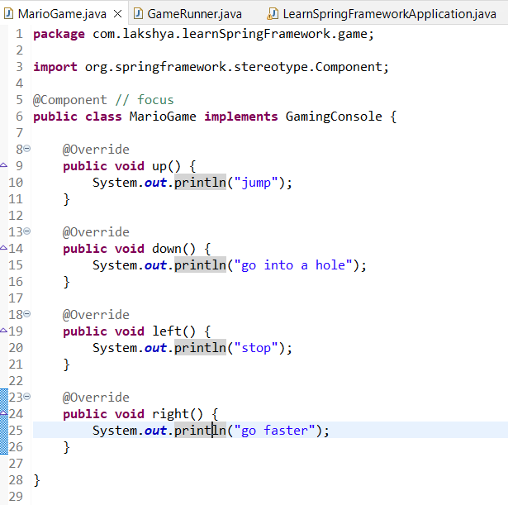

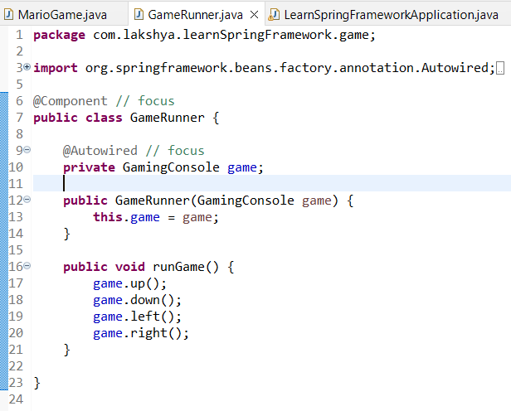

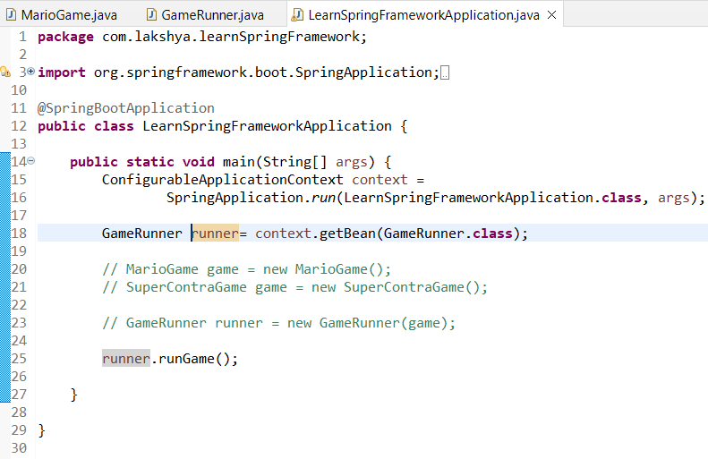

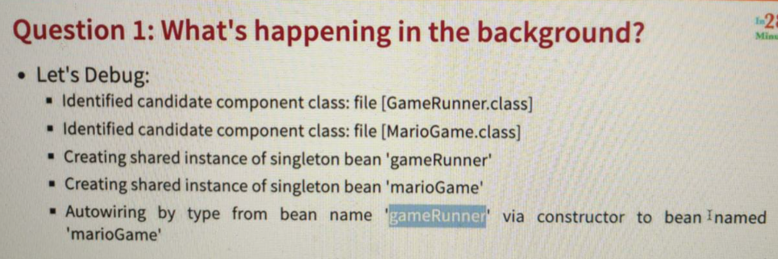

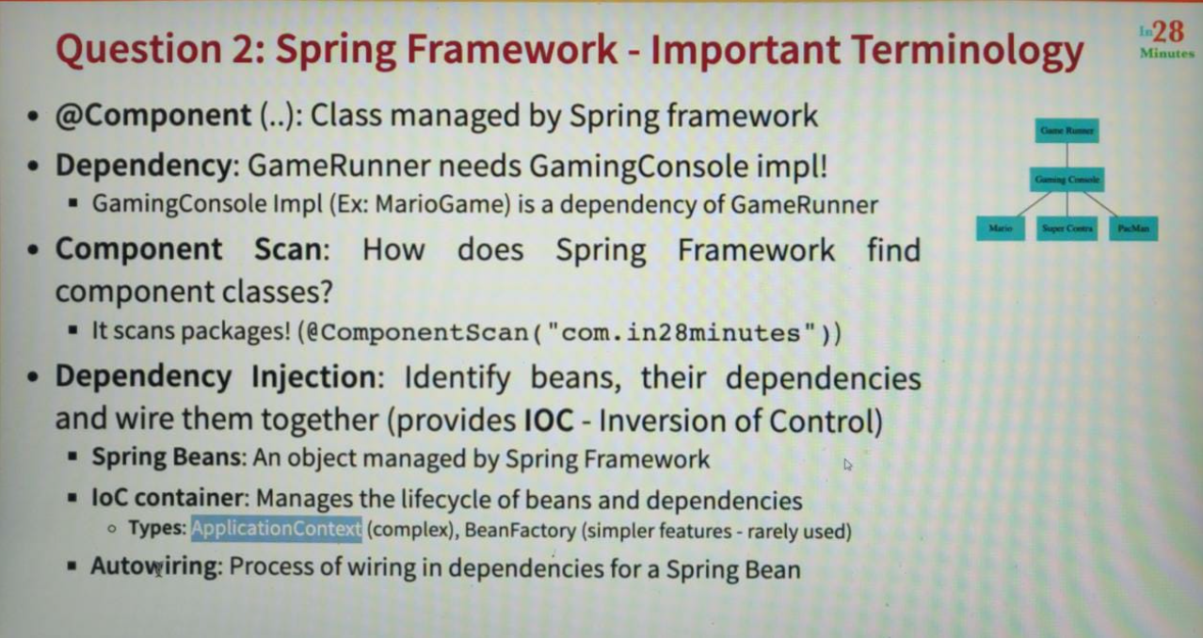

A dependency is something a class needs so that it can do it functionality the game rather needs to be able to run a game. So gaming console or implementation of a gaming console is a dependency of GameRunner class.

By default the Spring Framework scans for components within the same package (happens by default). It looks at all the classes within the same package and checks if any of them have the component annotation.

Why is it called the inversion of control? Earlier, as a programmer, you are responsible for creating all the classes. You are responsible for creating the Mario game. You are responsible for creating the super contra game, and you are responsible for wiring the Mario game into a game class. However, right now, we give that responsibility to spring framework, so instead of the programmer having the control, the control of creating objects and wiring them together is now with this spring framework. And that's the reason why this is called inversion of control.

A string bean is nothing but an object managed by this spring framework. Once spring framework finds component classes it goes and creates instances for them. Spring framework creates an instance of the mario game spring. It creates an instance of the game runner. These instances are also called spring beans. These are beans or objects which are managed by the spring framework, the creation of the object, the life cycle and the destruction of the object. Everything is automatically done by the spring framework and that's why these are called spring beans.

The next important terminology that you would often hear is IOC container. We talk about IOC as inversion of control. What is IOC container? The technical component inside this spring framework which implements the dependency injection logic is what is called the IOC container. So dependency injection is a concept and the dependency injection feature enabling framework is provided by a IOC container which is present in spring framework, the popular types of IOC containers are application context and bean factory.

So we are using application context. What we are doing is putting applications that run and then spring application.run would create an application context for us and from the application context is where we are picking up our beans. One of the important responsibilities of IOC container is autowiring. Basically, it's all about identifying the dependencies and wiring or injecting the dependencies into the bean.

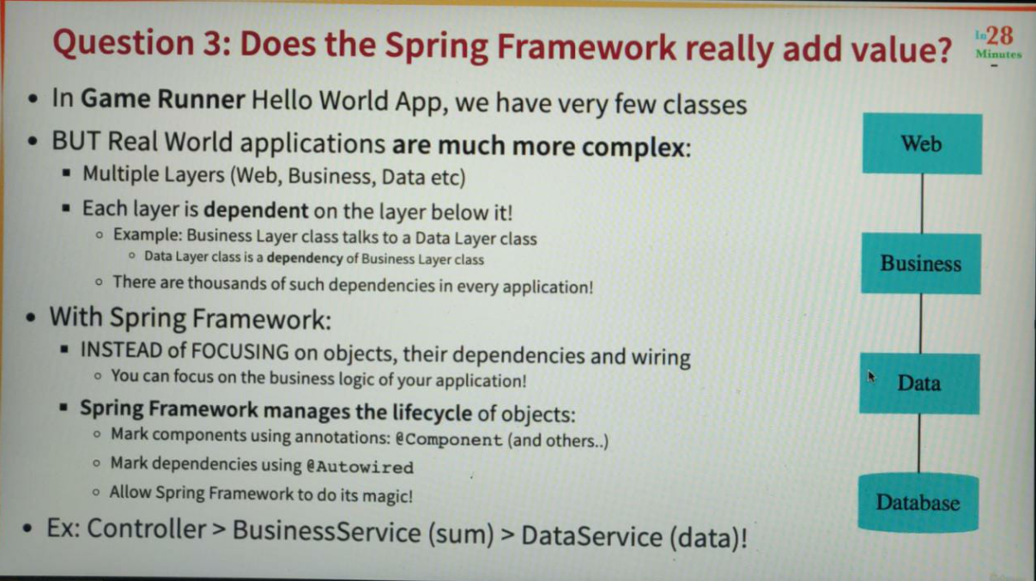

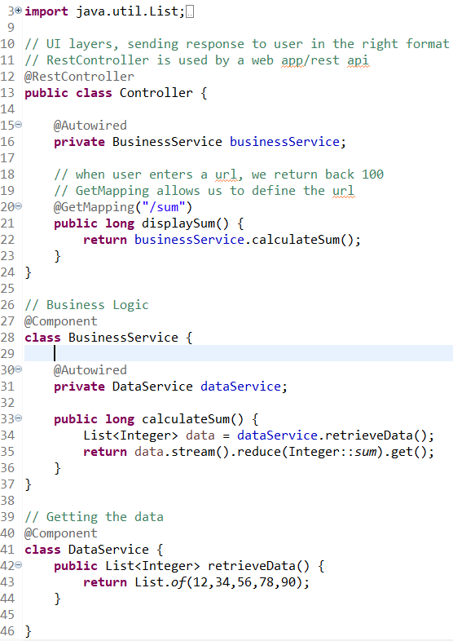

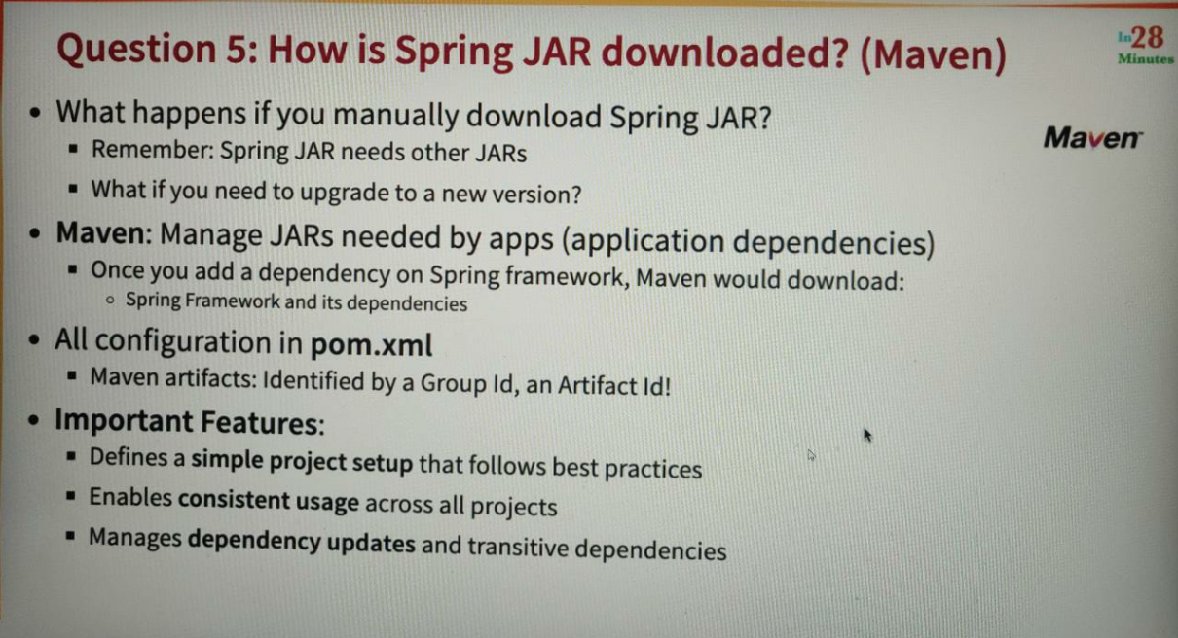

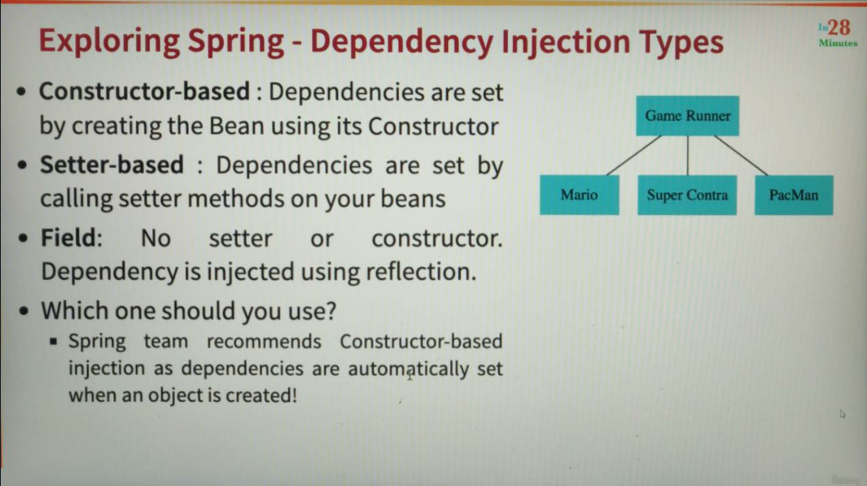

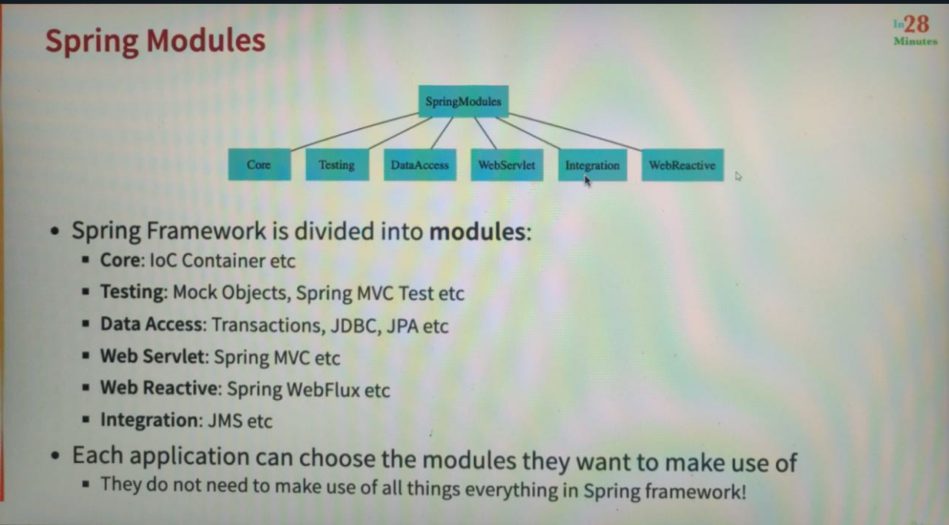

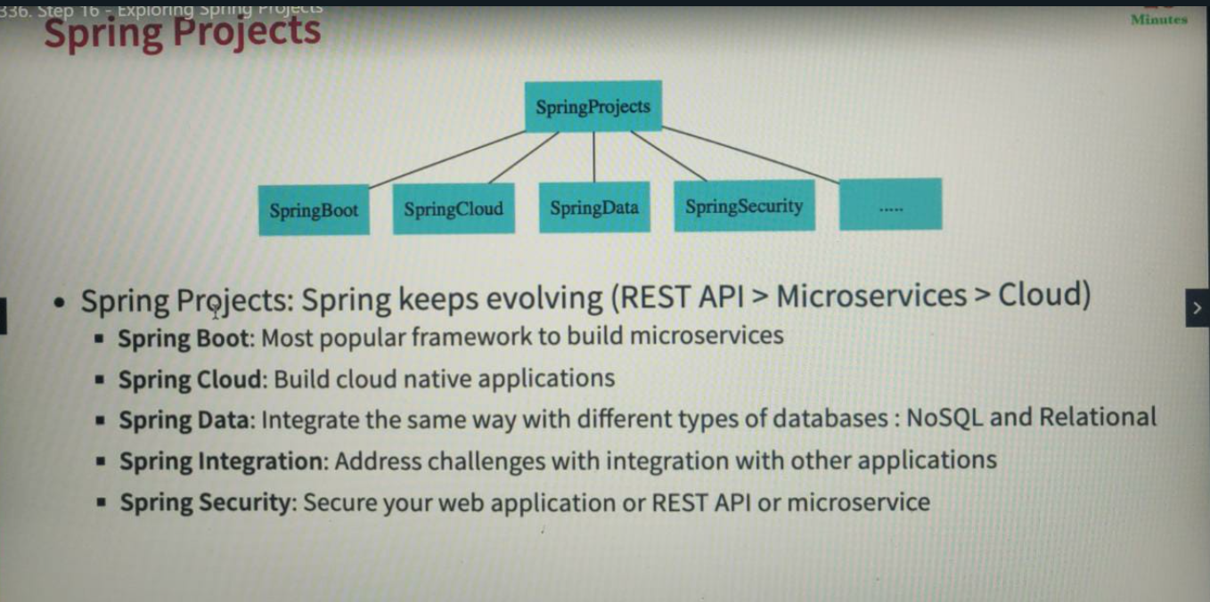

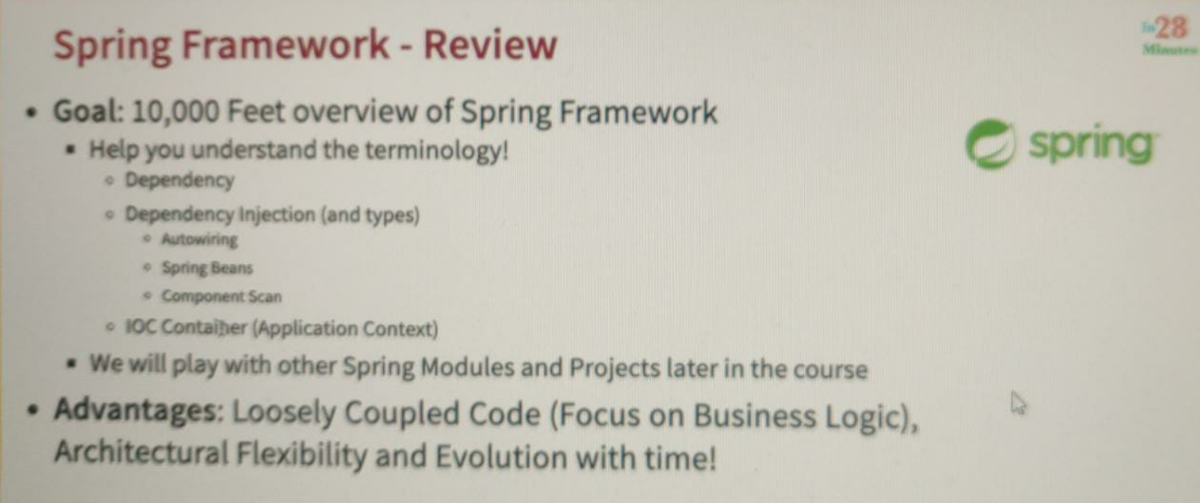

**Spring Boot**

The two most important parts of the magic behind Springboot is Springboot Starter Projects and Springboot auto configuration. Springboot starter projects define the different dependencies that are needed to build different kinds of applications and springboot auto configuration would look at those dependencies, would look at all the classes which are available, and it would provide auto configuration that is typically needed with that kind of application. If I'm developing a web application, I would want to configure a servlet. I would want to configure a server where I would want to run the application and I would want to configure default error pages. I would want to configure to flow conversion from Json. All that configuration is automatically done so that you focus on your business logic. The end objective of Springboot is to help you focus on the application you are building, not worry about the frameworks or the configuration that is needed by the frameworks.

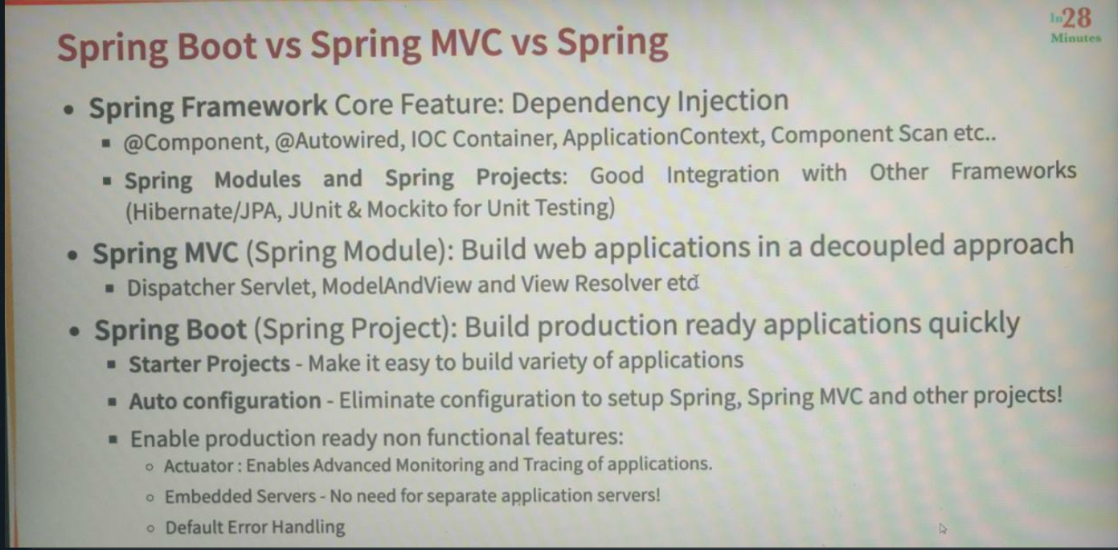

<https://www.udemy.com/course/java-programming-tutorial-for-beginners/learn/lecture/25694078#questions>

**Section 27: Simple Rest API**

